**Python for Bioinformatics**

Exercise 3

**III-Title: Programs demonstrating use of Lists and Tuples**

1. Write a program demonstrating declaration, accessing- Indexing and splicing of lists and its elements.

**Algorithm**:-

Step 1: In python a list is declared by placing all the items (elements) inside square brackets [], separated by commas and assigning it to a variable.

Step 2: The list is accessed by printing the variable to which the list has been assigned to.

Step 3: To access the list items refer to the index number inside the index operator[] (INDEXING) [].

Step 4: To print a subset of values present in lists, input the start and end number of the subset in the index operator []

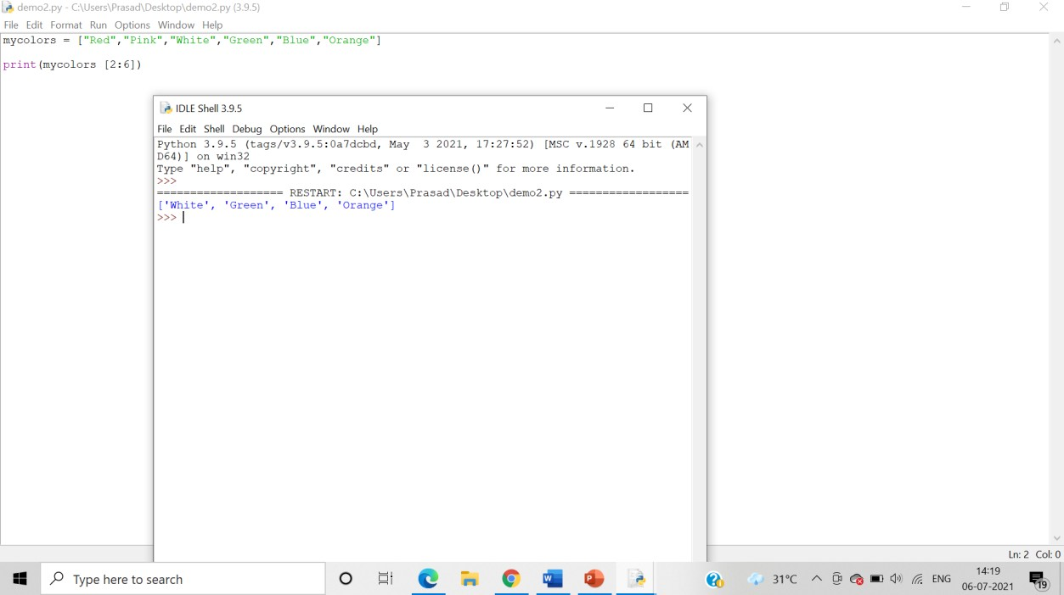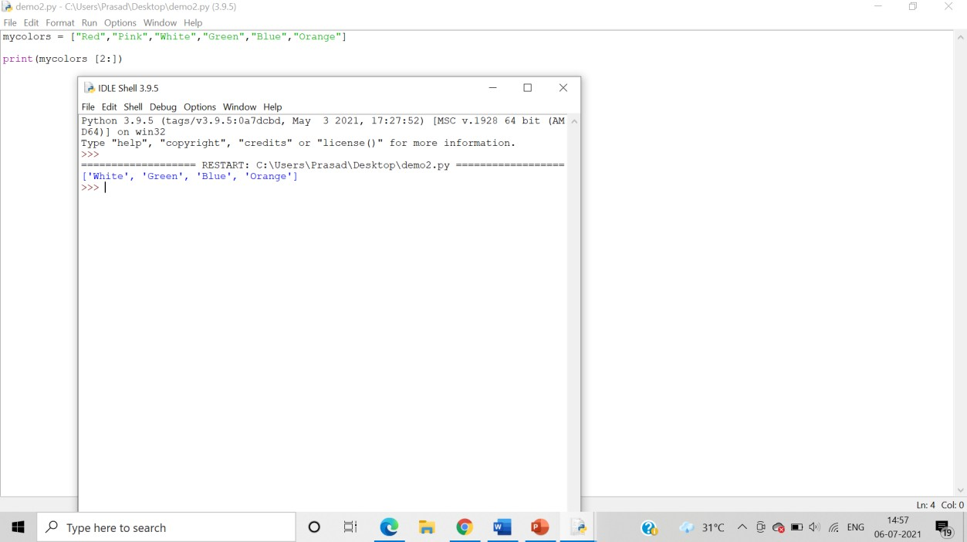Answer: Program demonstrating splicing:

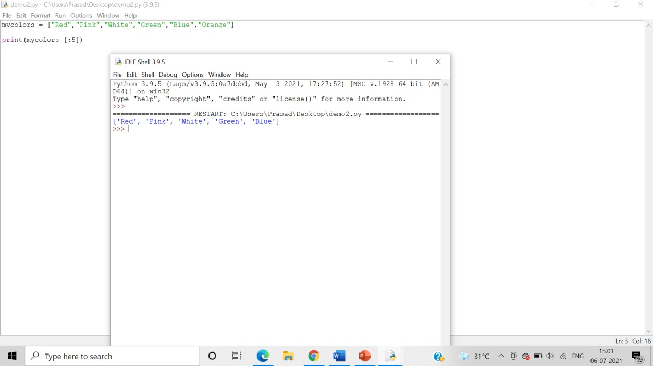

Using negative index:

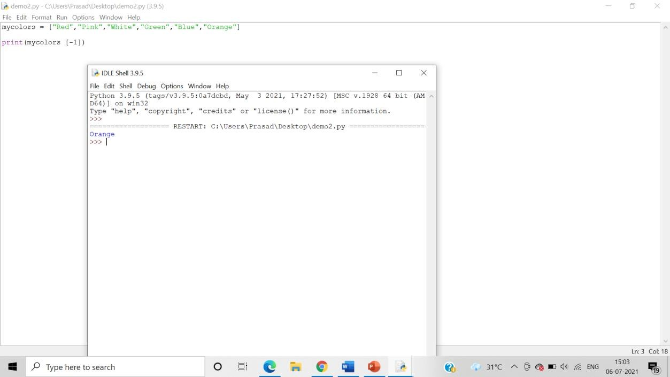

Splicing using negative index:

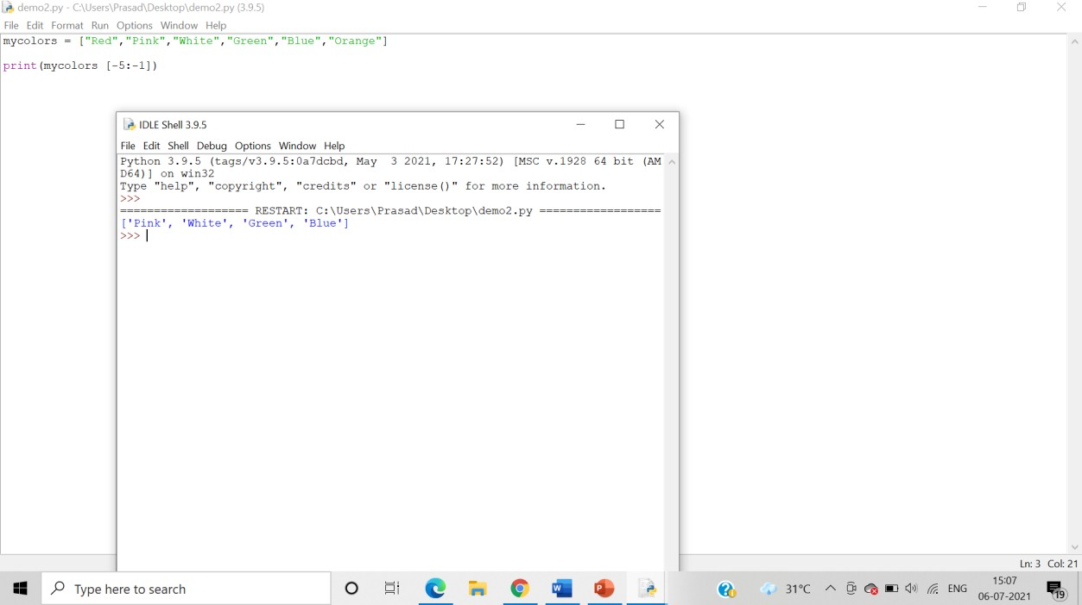

1. Write a program demonstrating input of list elements from the user.

Step 1: Use the input() function to take user input and assign it to a variable

Step 2: Use the split function to split each value in the variable with a “,” and assign it a new list variable.

Step 3:Print the list variable

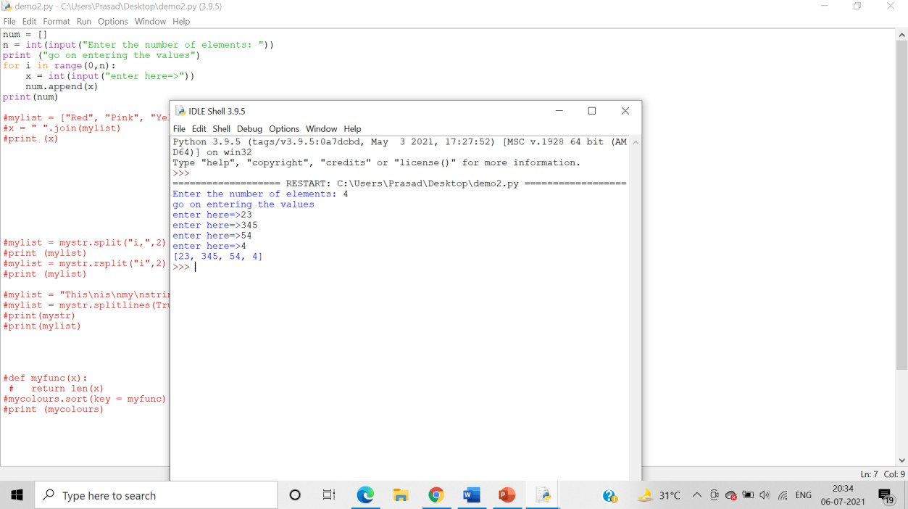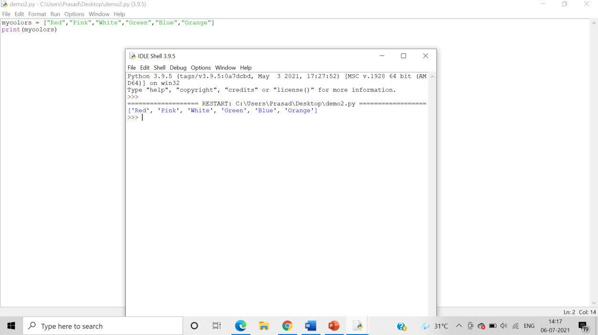

Using list constructor:

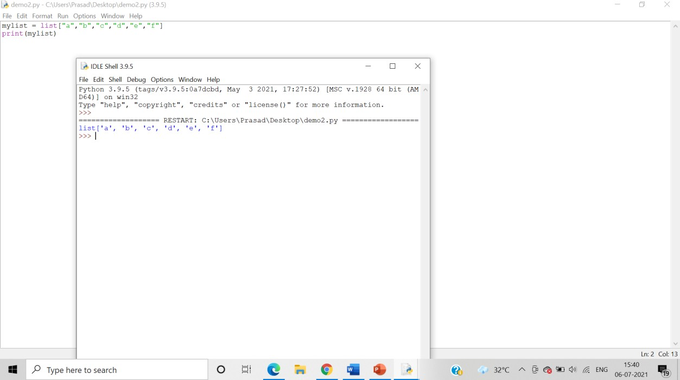

Creating copy of list:

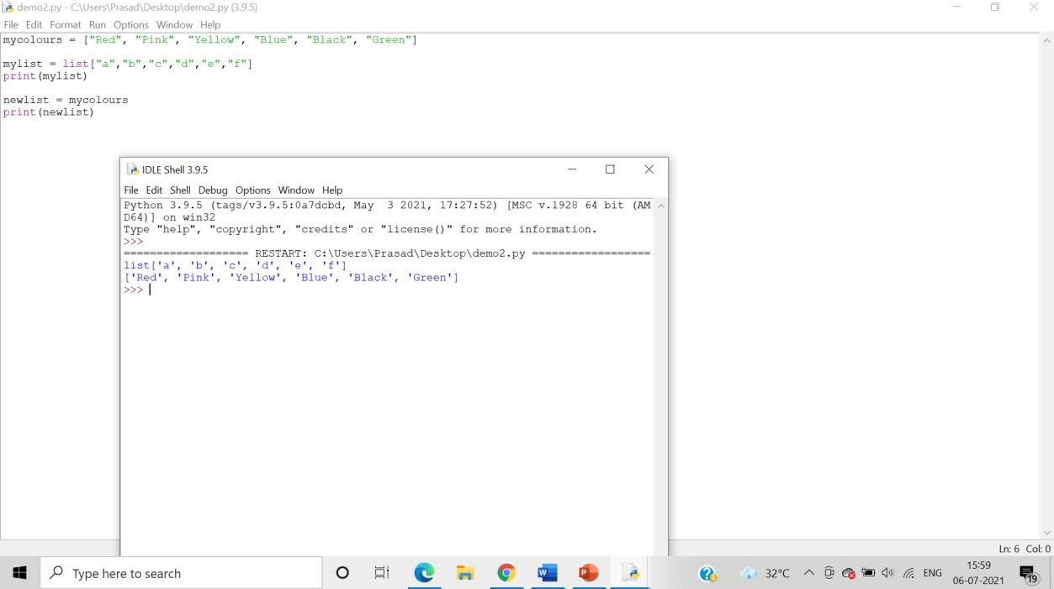

Creating copy of list using list constructor:

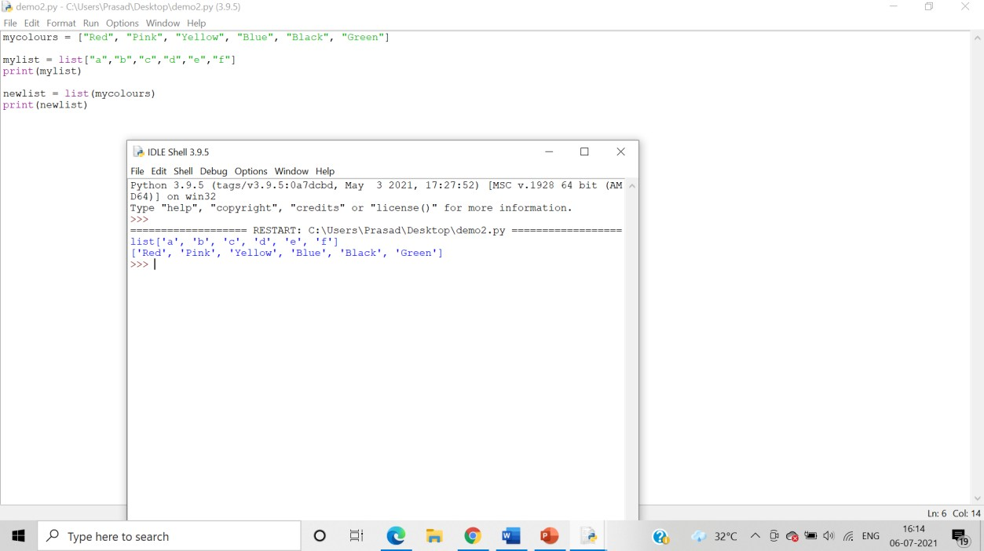

1. Write a program demonstrating printing of list elements using for in and range() function

Algorithm:-

Step 1: Declare a list by assigning it to a variable

Step 2: The range() gives us a sequence of numbers in between the two integers given to it.

Step 3: We can use the in and range() function to print the list elements using a for loop.

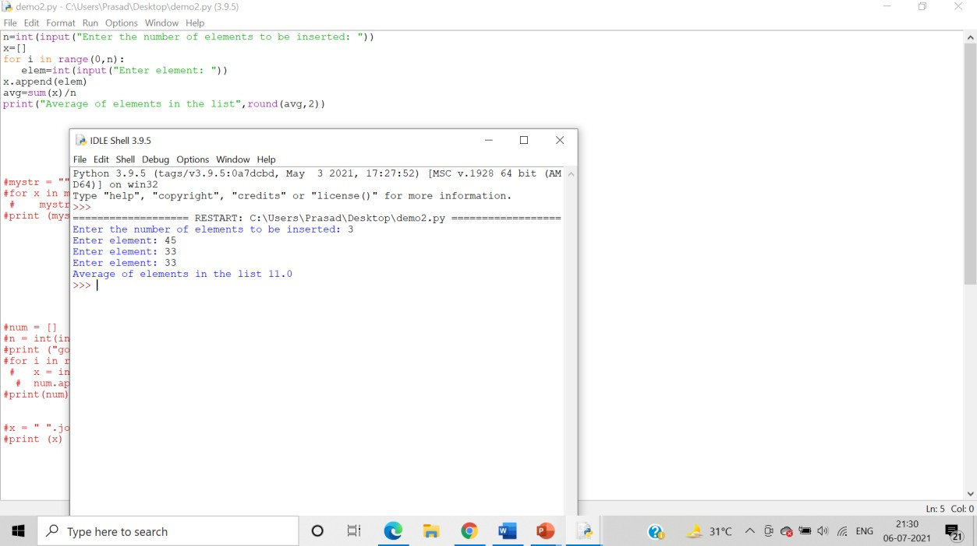

1. Write a program demonstrating len() and del() function.

Algorithm:-

Step 1: The len() function is used to obtain the length of the list

Step 2: The del() function deletes all the elements in range starting from index ‘a’ till ‘b’ mentioned in arguments.

Len()

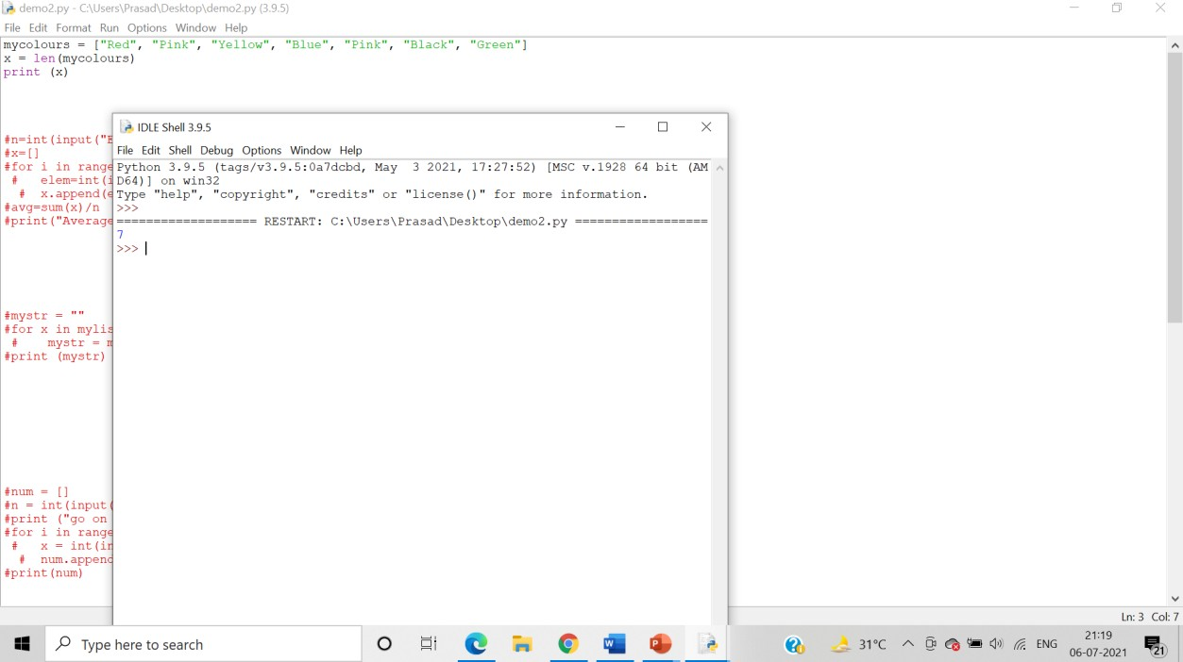

del()

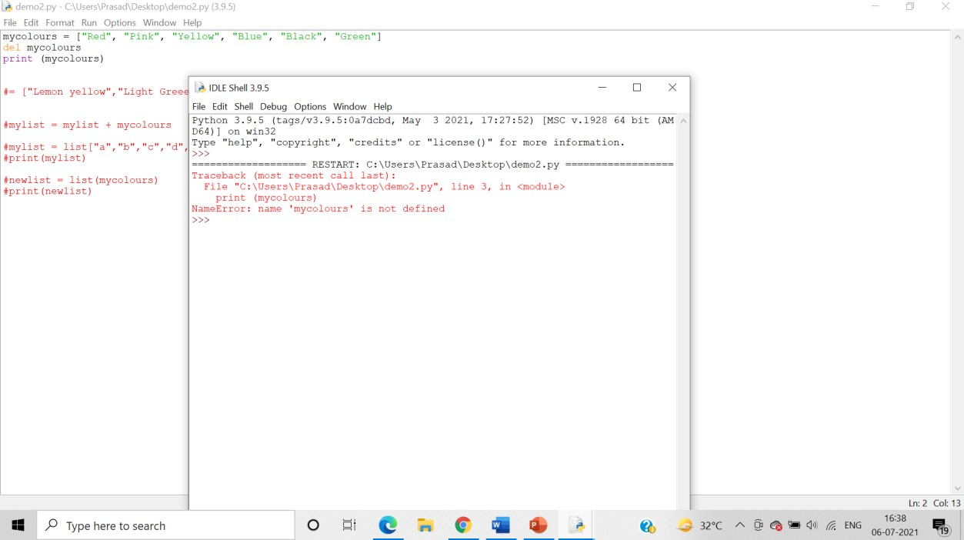

1. Write a program demonstrating usage of ‘+’ and ‘*’ operators on lists Algorithm:-

Step 1: The ‘+’ operator is used to concatenate the 2 lists into a single list.

Step 2: The ‘*’ operator is used to to**multiply the list “n” times**.

Program demonstrating usage of ‘*’ operator:

Code: Program demonstrating usage of ‘+’ operator:

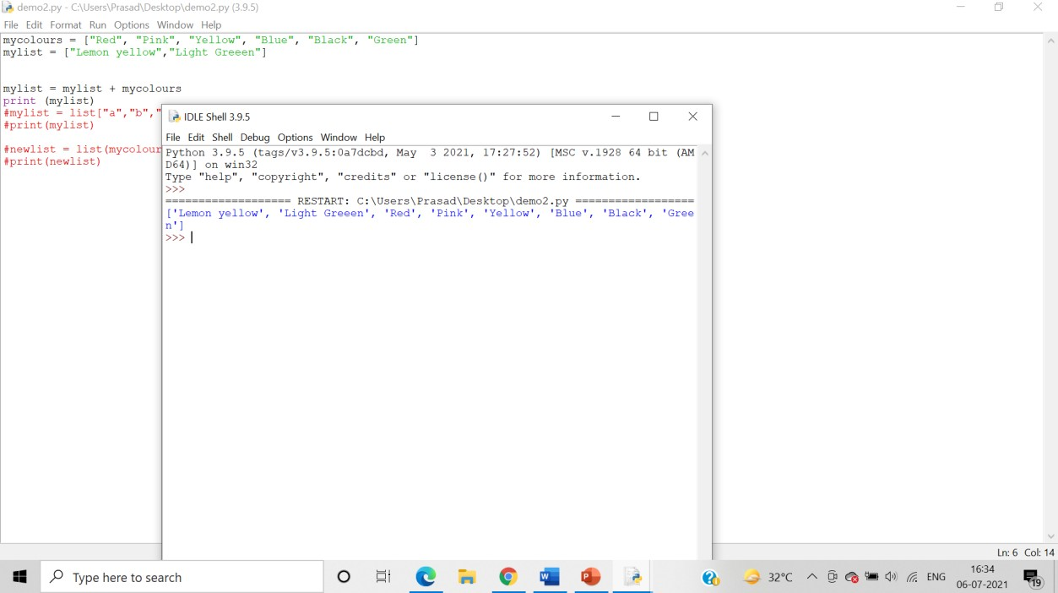

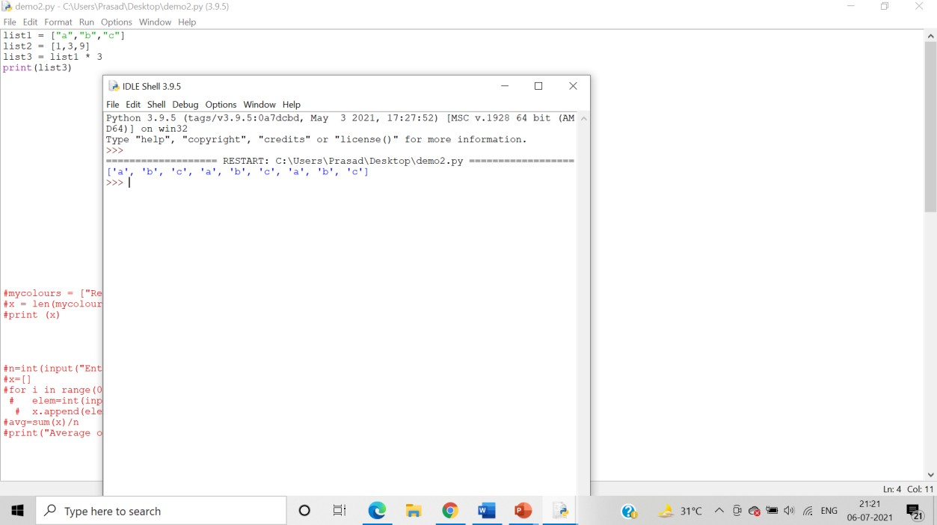

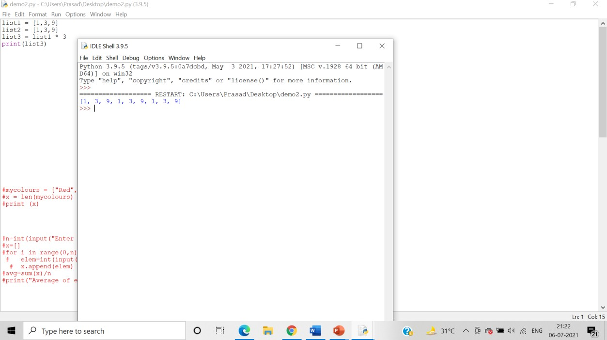

1. Write a program demonstrating “in” and “not in” keywords on lists

Algorithm:-

Step 1: - The ‘in’ operator is used to check if an element is present in the list or not. Returns true if element is present in list else returns false.

Step 2:  The ‘not in’ operator is used to check if an element is not present in the list or not. Returns true if element is not present in list else returns false.

Answer: Program demonstrating “in” keyword: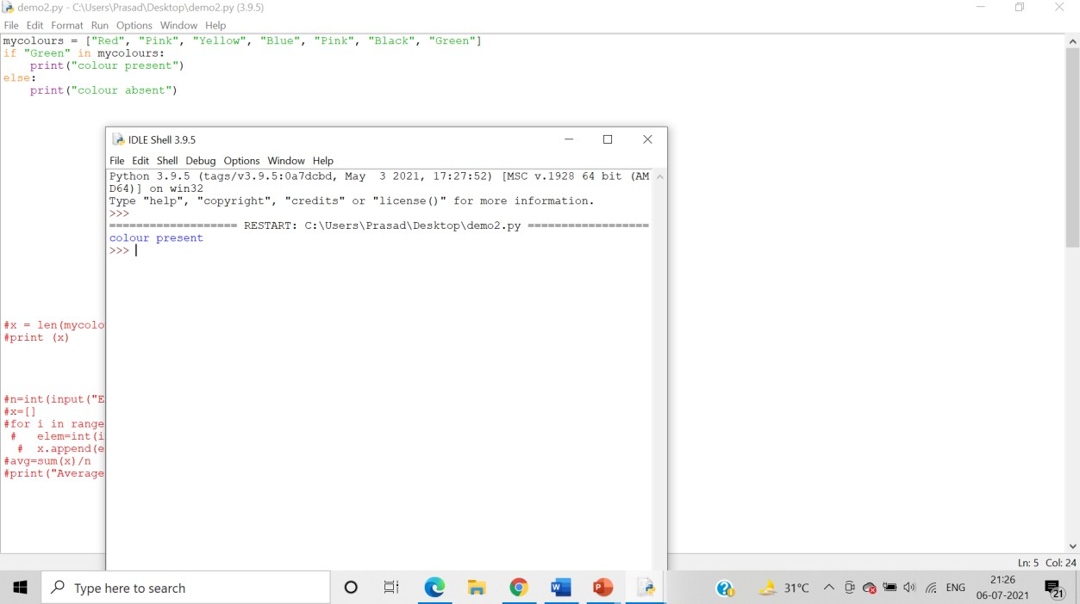

Program demonstrating “not in” keyword:

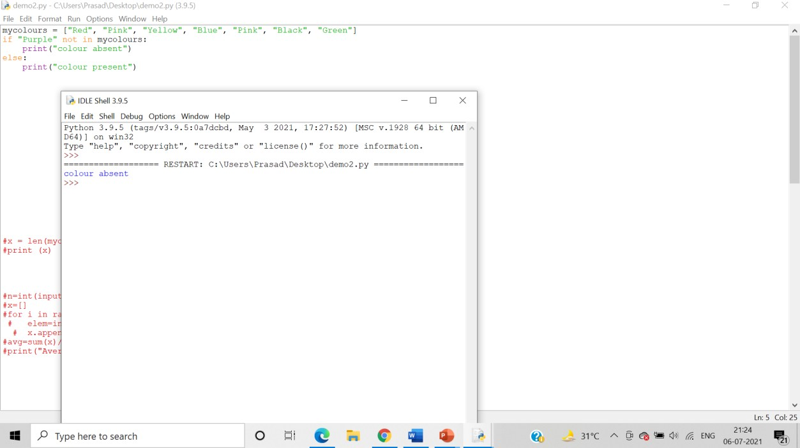

1. Write set of programs for demonstrating the usage of all the different Lists methods along with their variations

Algorithm:-

Step 1: The append() function is used to add values to a given list.

Step 2: The clear() function is used to erase all the elements of list. After this operation, list becomes empty.

Step 3: The copy() function is used to copy elements in a list and to assign it to a new variable.

Step 4: The count() function counts the number of occurrences of elements in list.

* + Append()

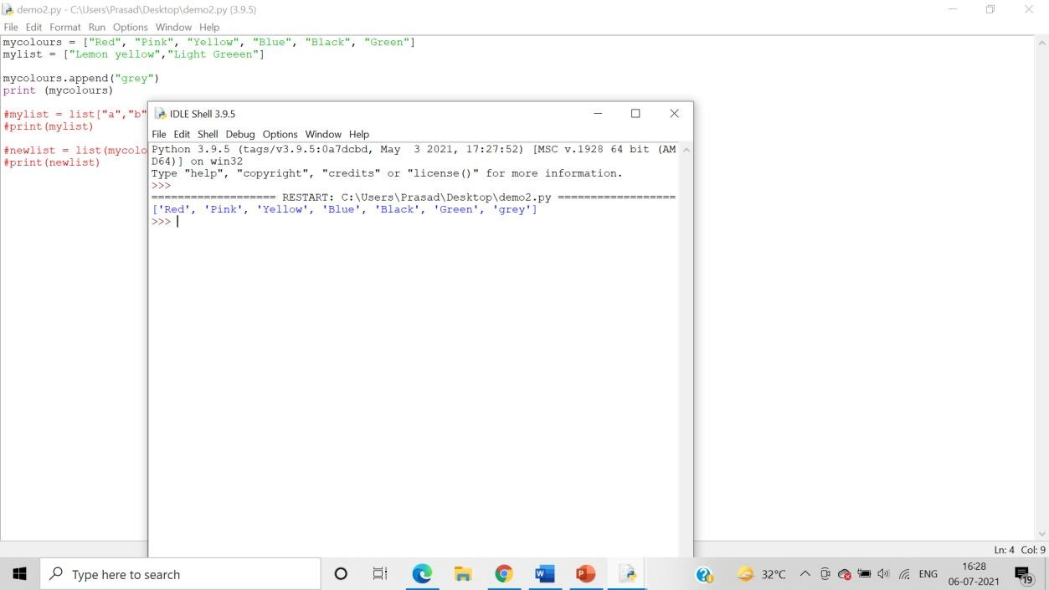

Adding 2 elements:

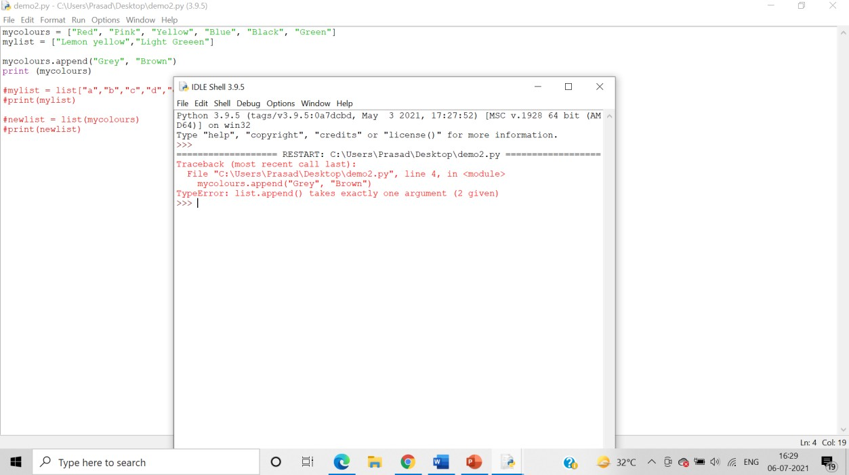

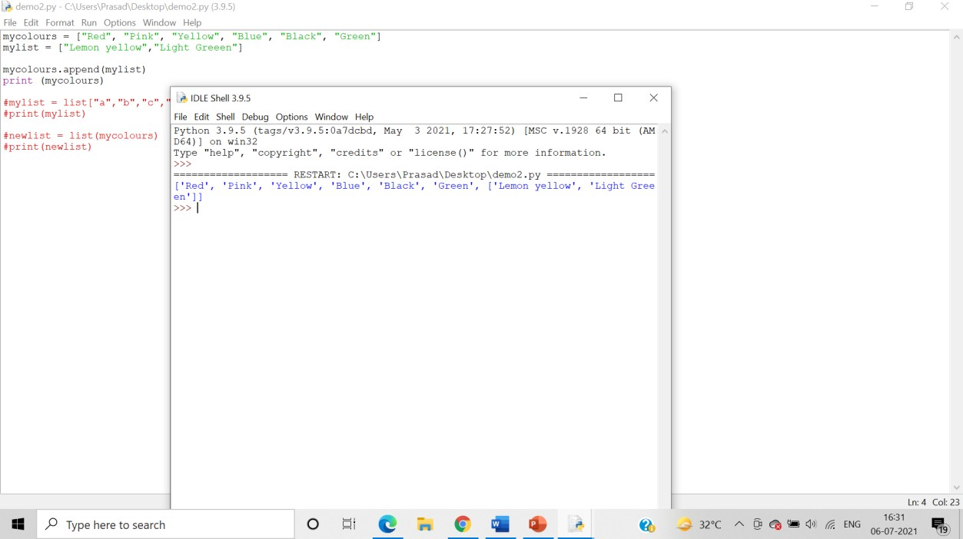

* Clear()

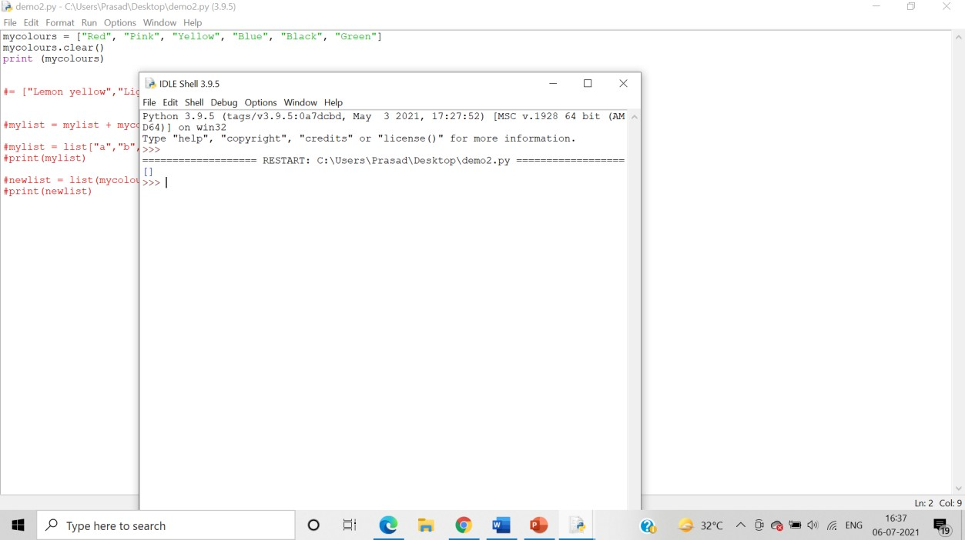

* Copy()

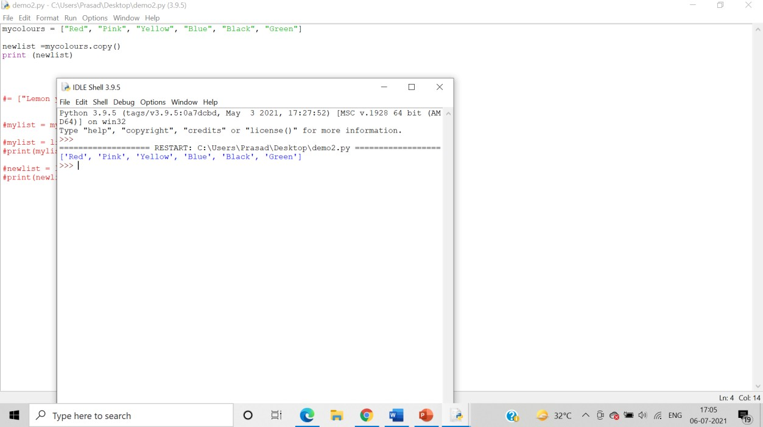

* Count()

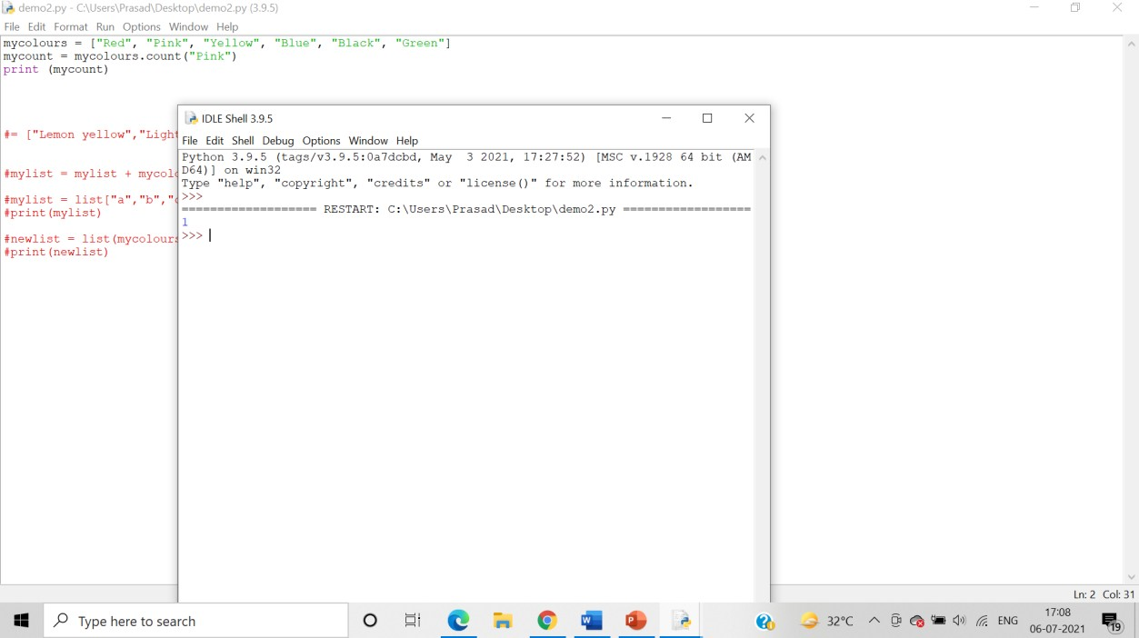

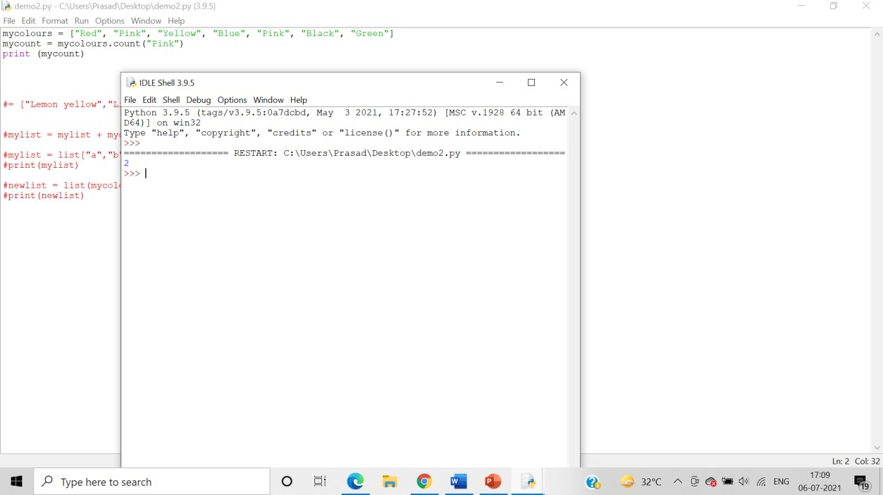

* Extend()

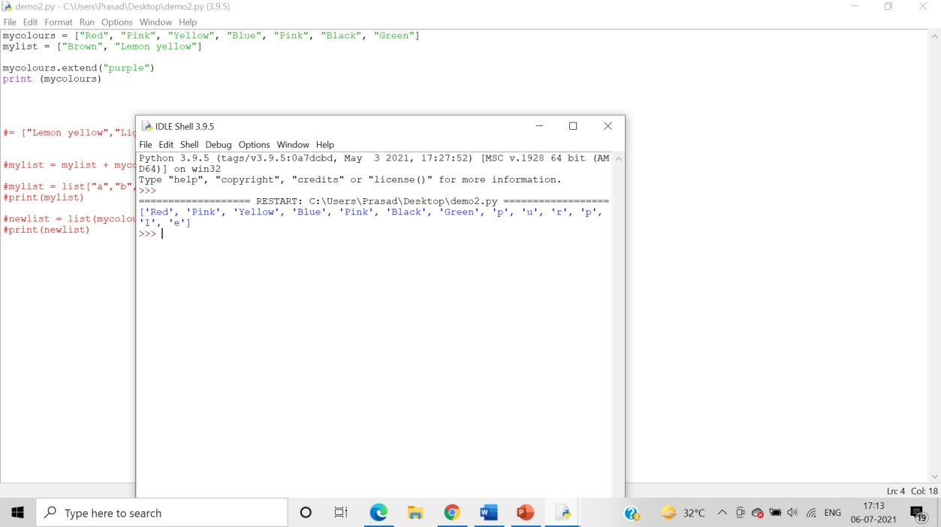

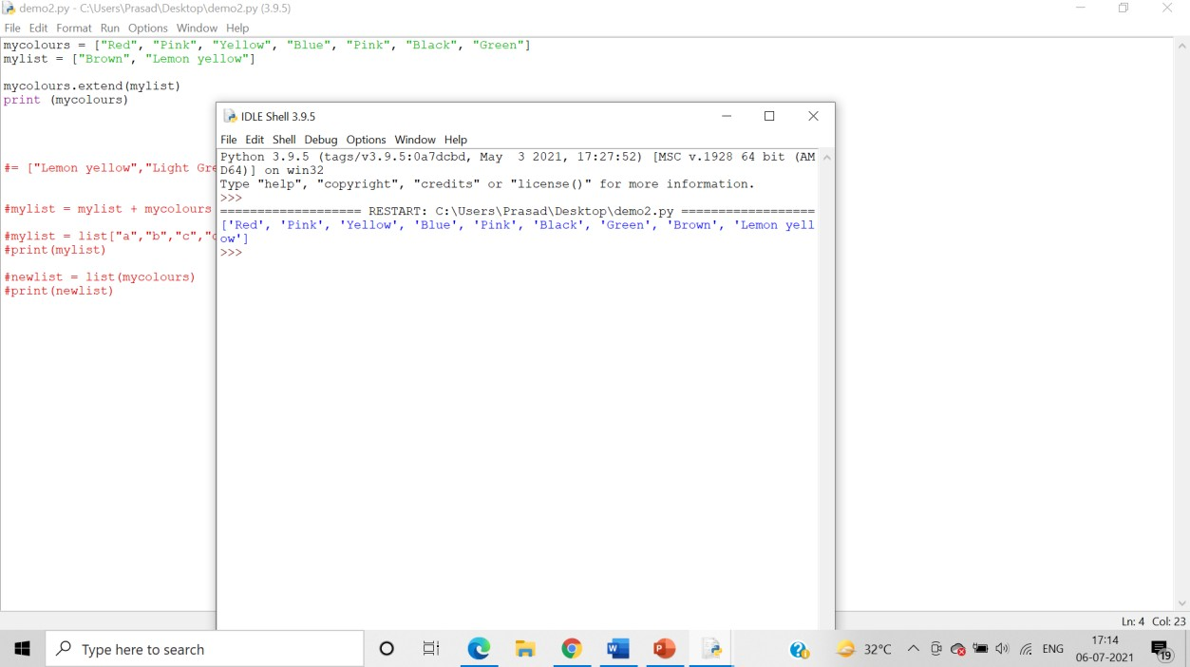

* Index()

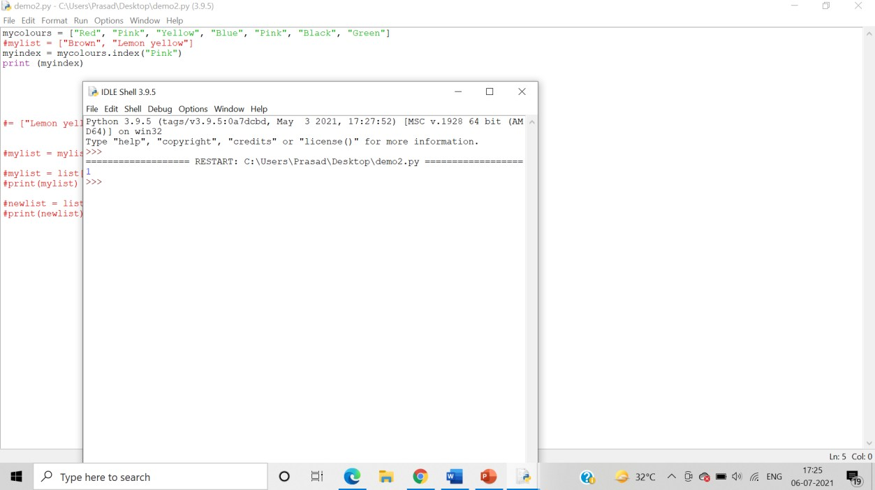

* Insert()

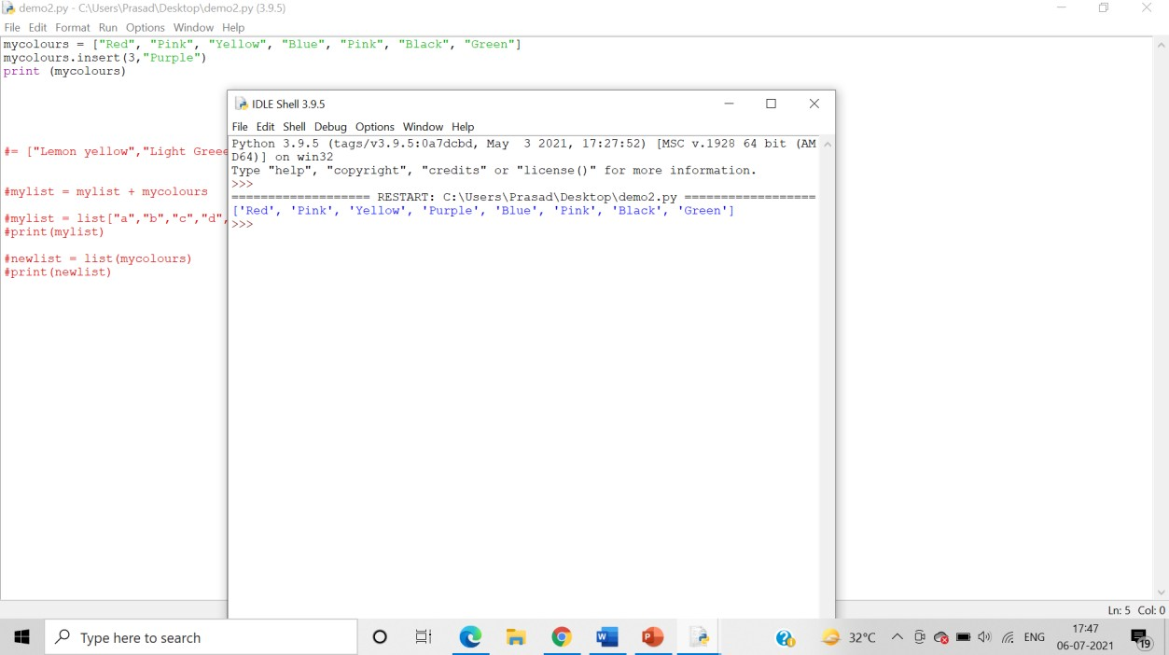

* Pop()

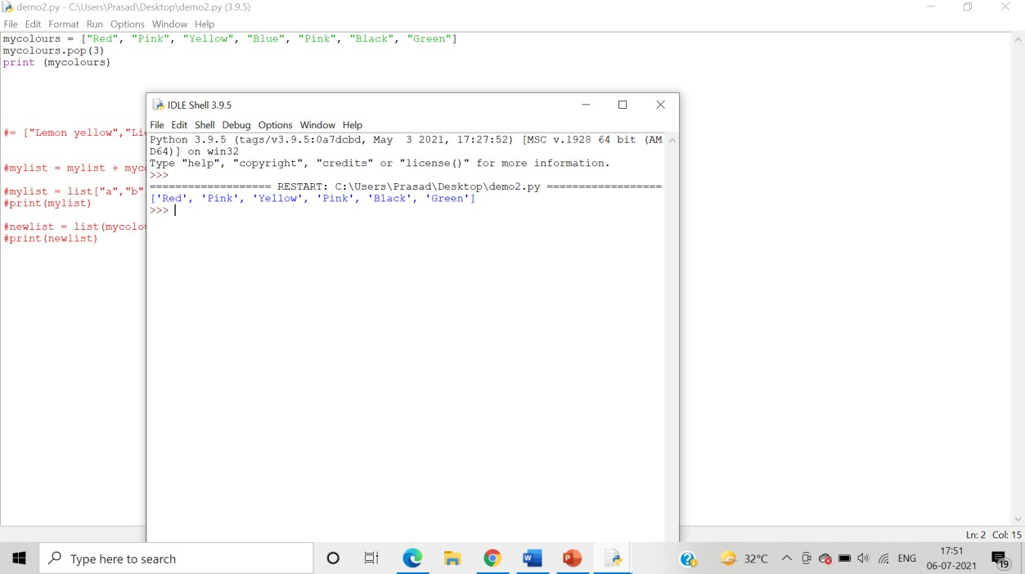

* Remove()

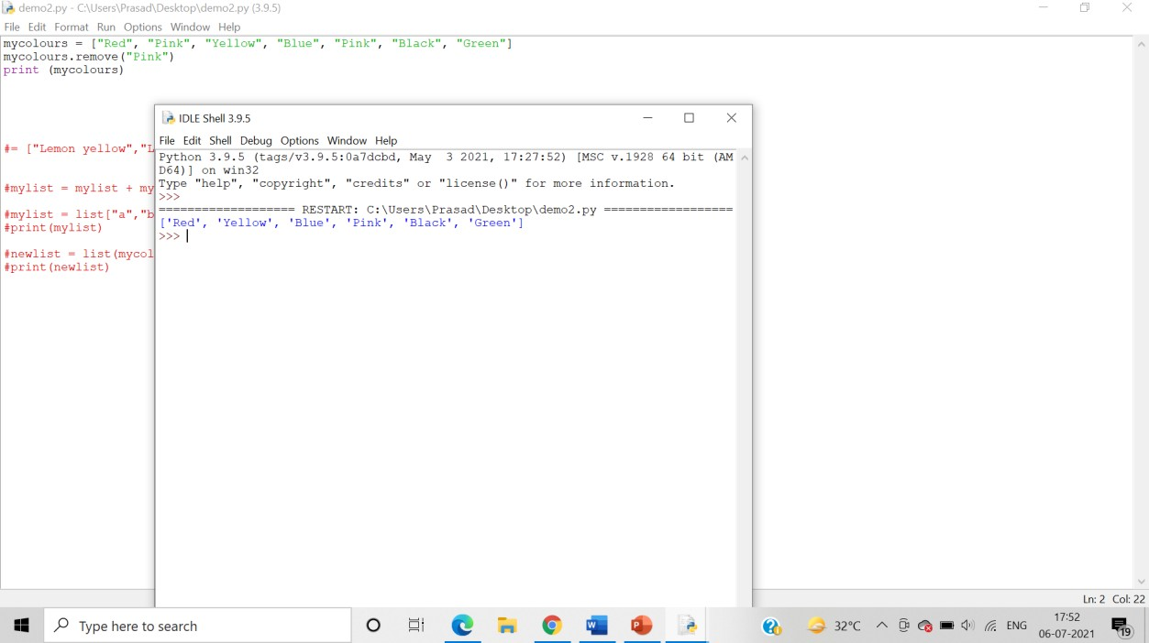

* Reverse()

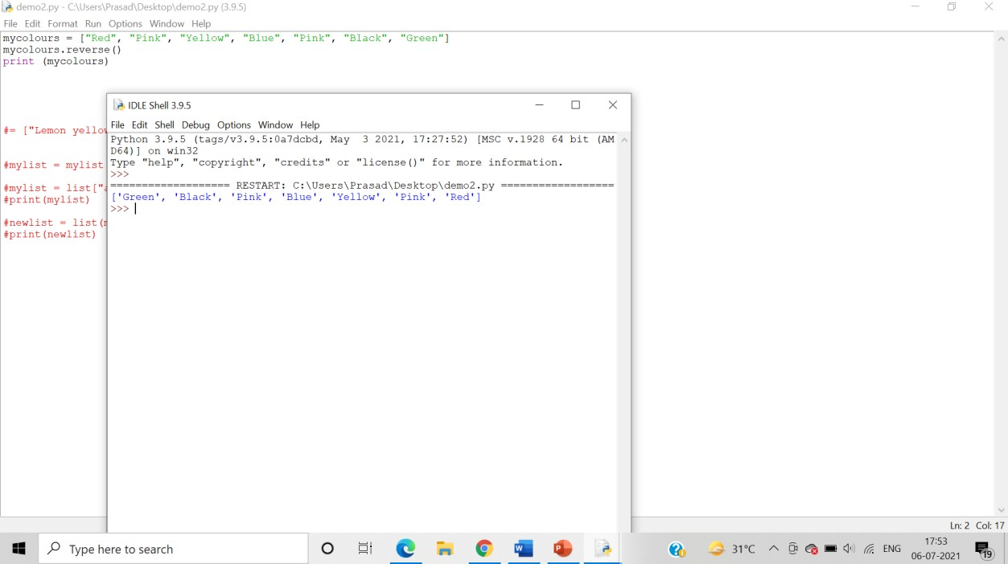

* Sort()

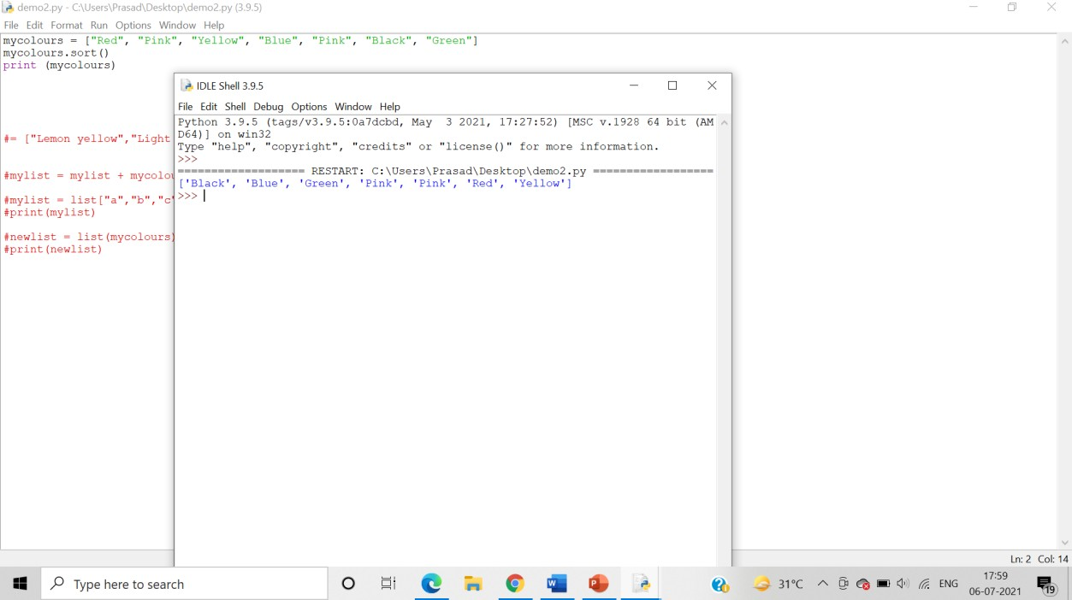

Using reverse parameters:

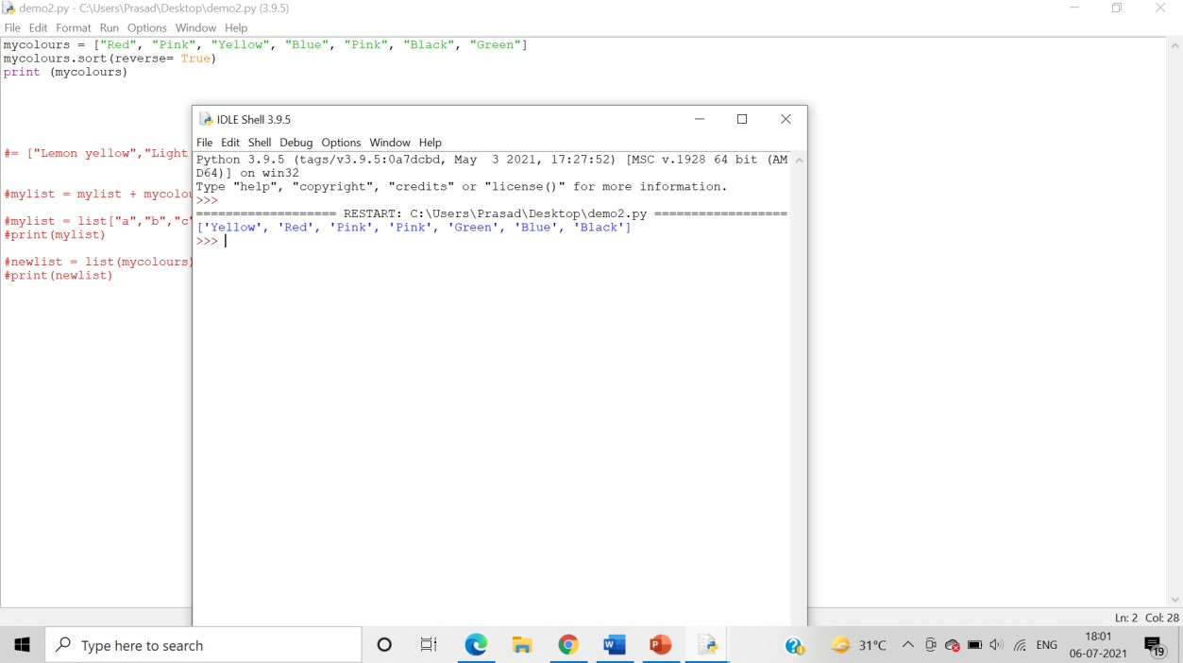

Declaring a function:

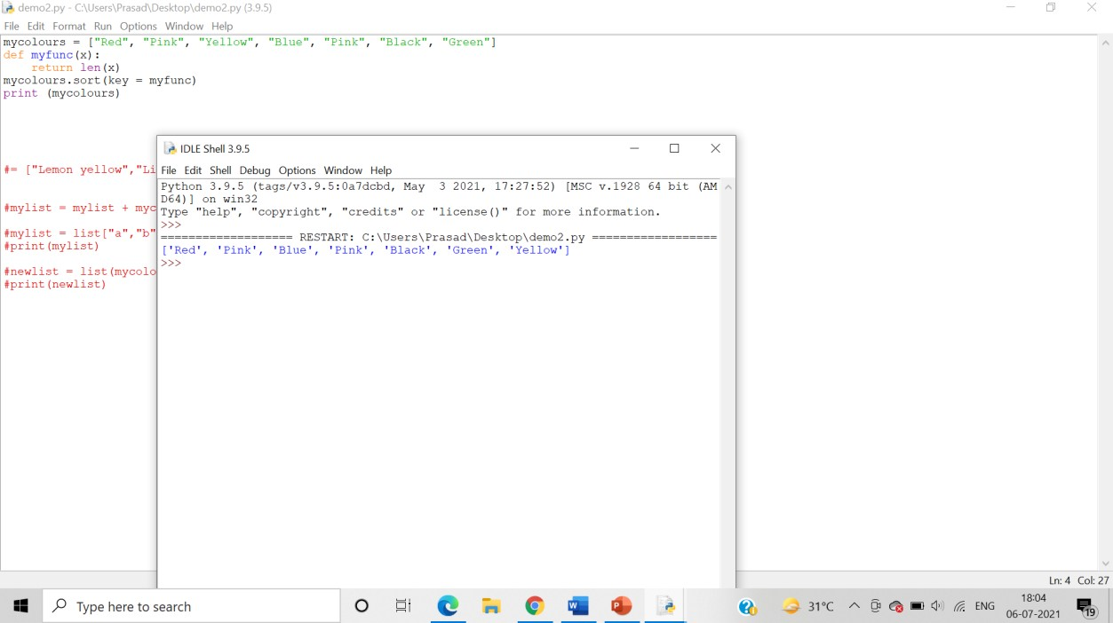

1. Write a program demonstrating conversion of string to list and list to a string

**Algorithm**:-

Step 1: We use the list() function to convert a string into a list.

Step 2: We the use the join() function to convert the values present in the list to a single string.

Answer: Program demonstrating conversion of string to list and list to a string: Splitting a string into a list (String Methods) –

* 1. split()

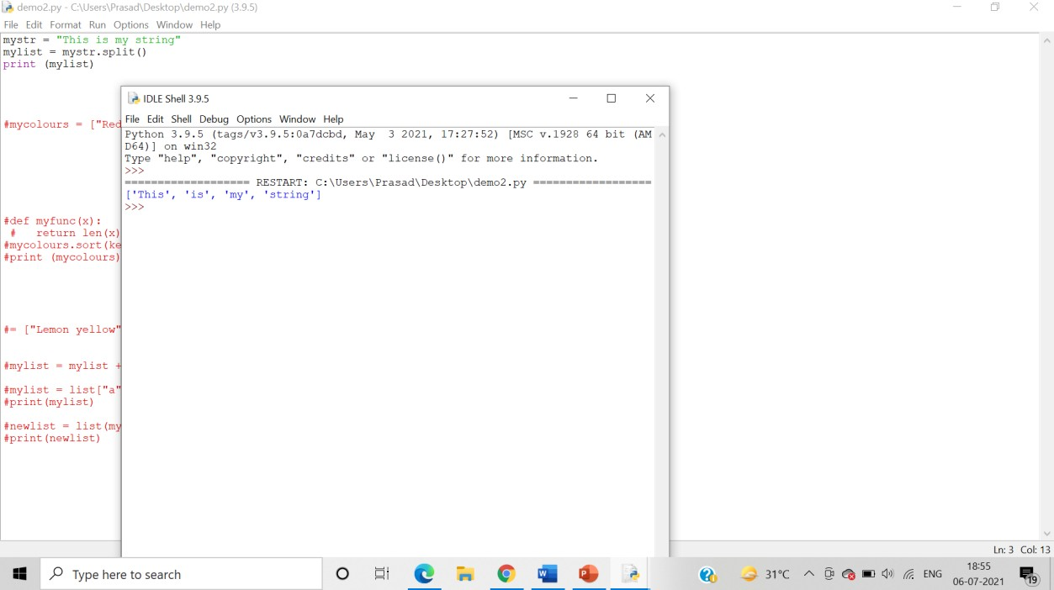

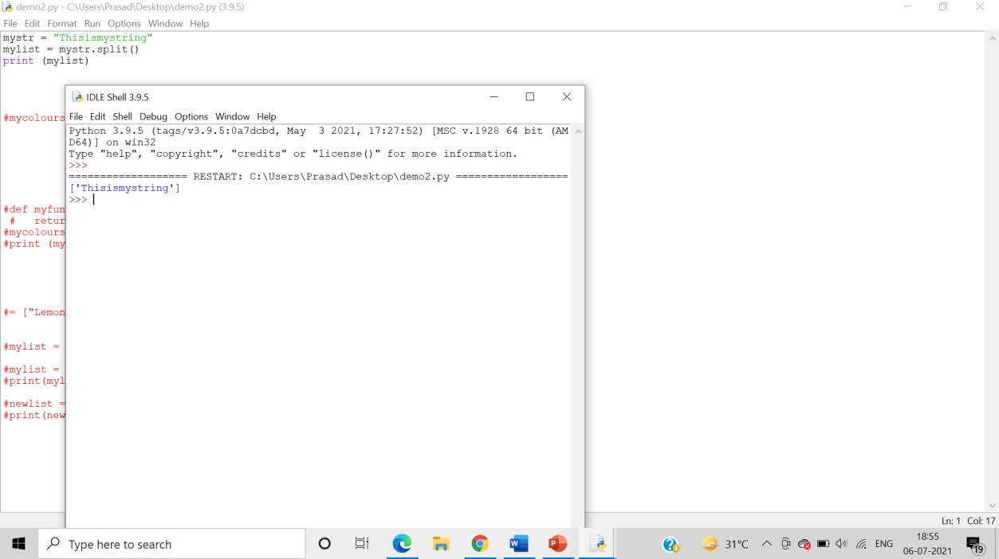

Splitting at the occurrence of “i”

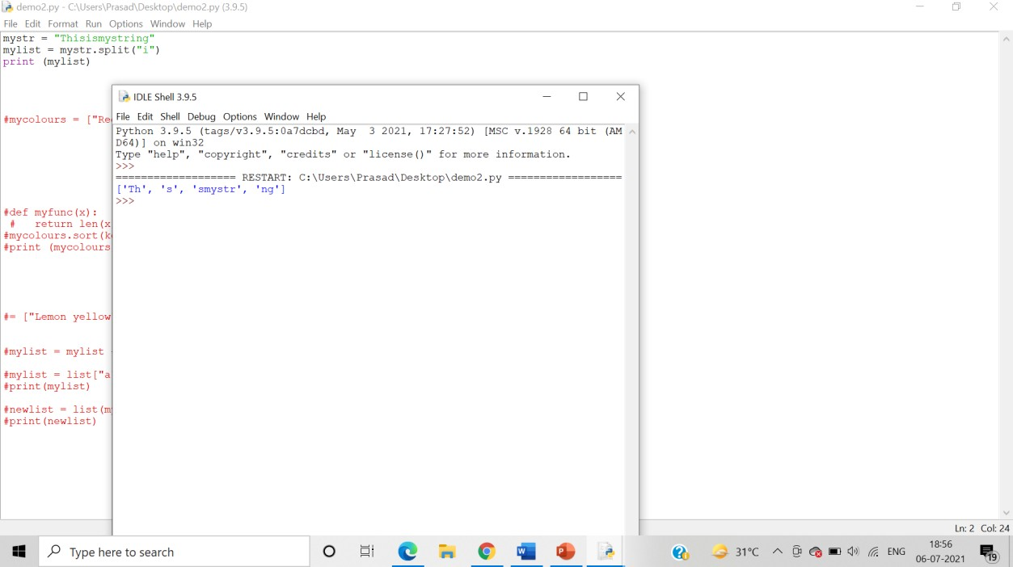

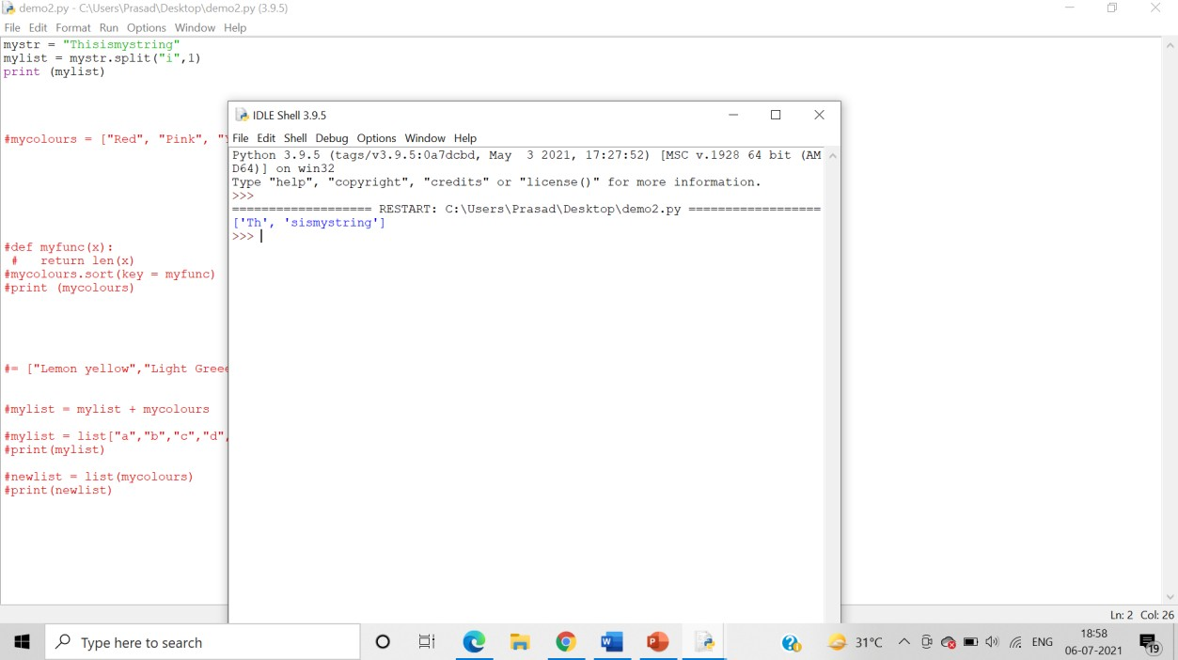

* 1. rsplit()

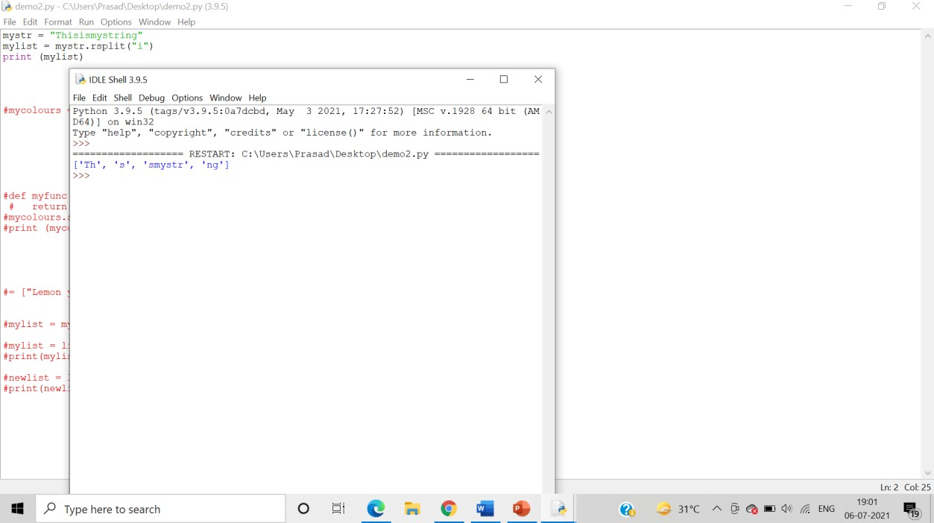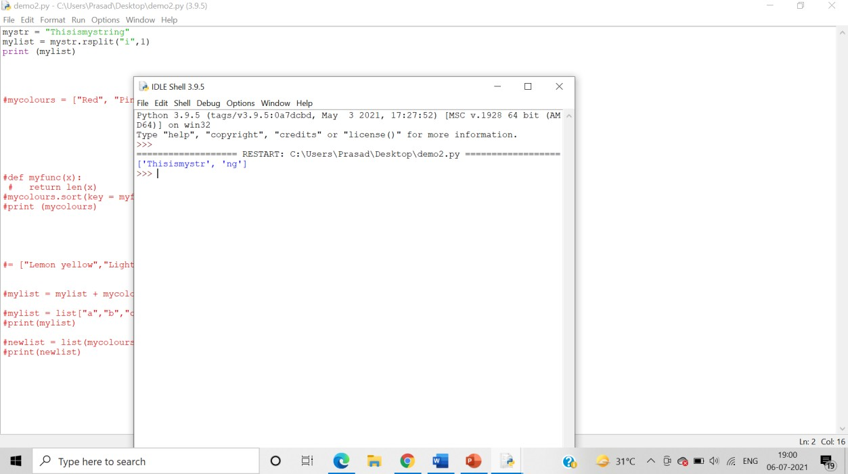

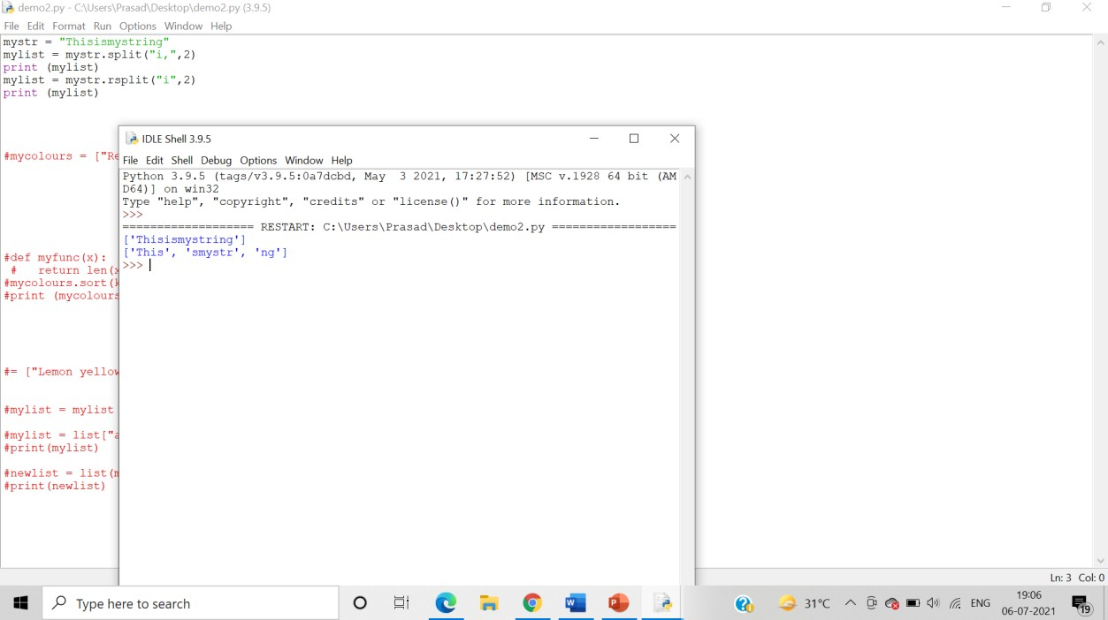

3. splitlines()

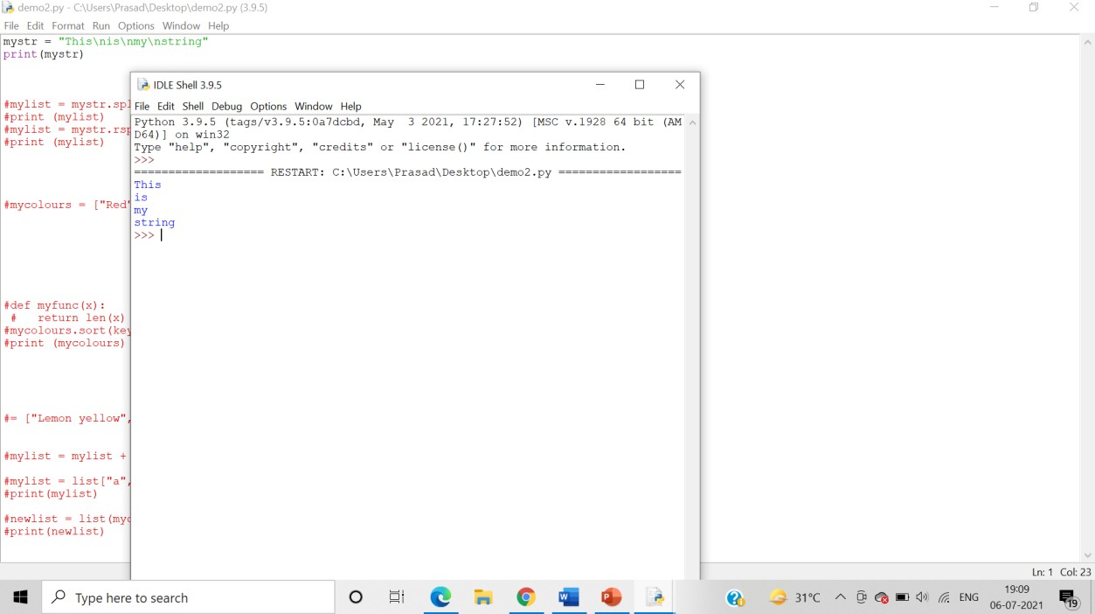

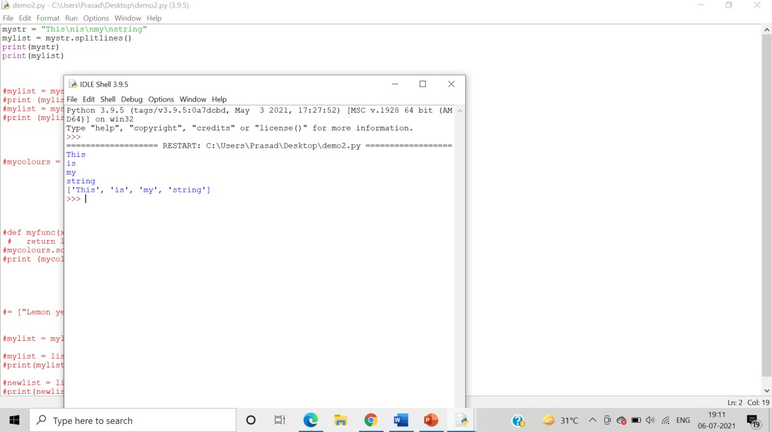

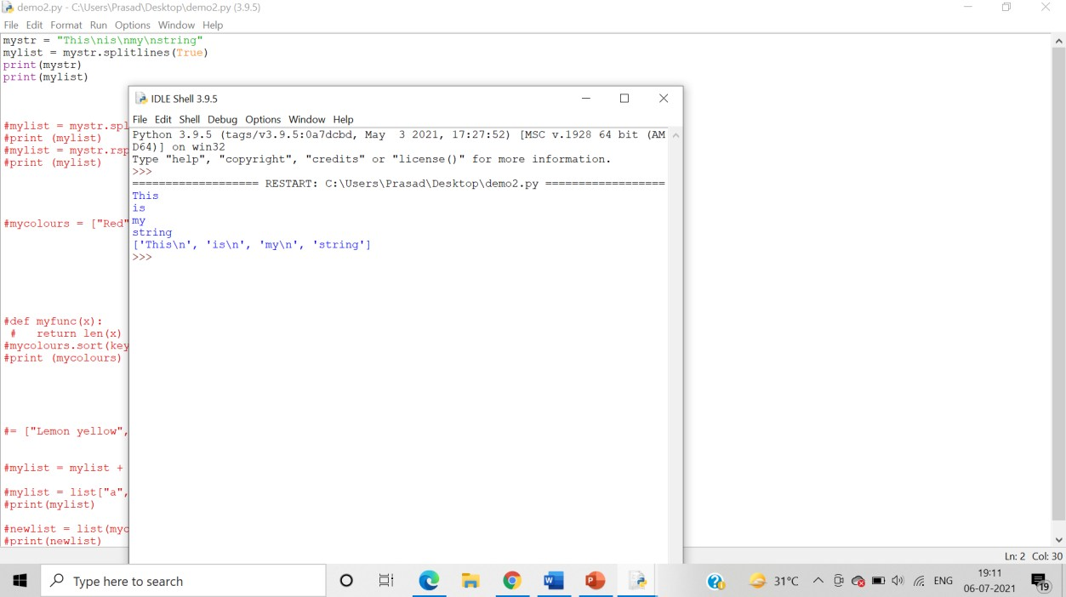

Joining a list into a string –

1. join() – list method

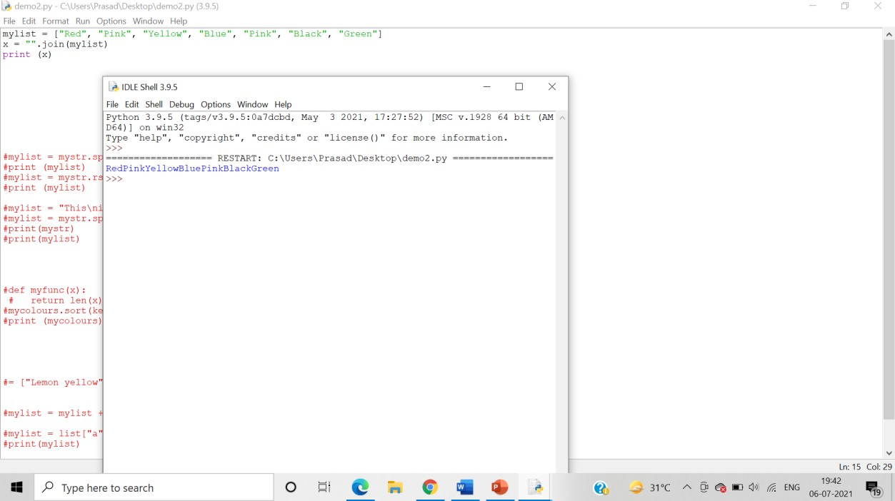

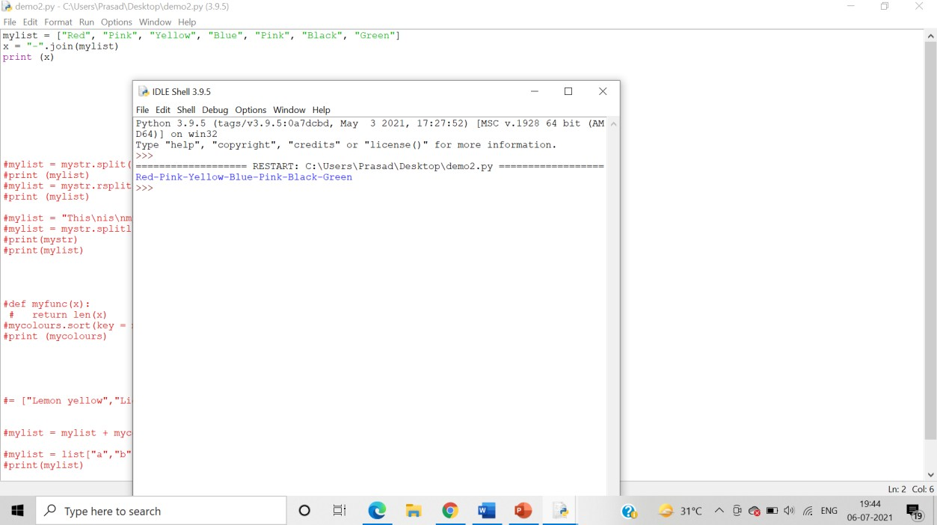

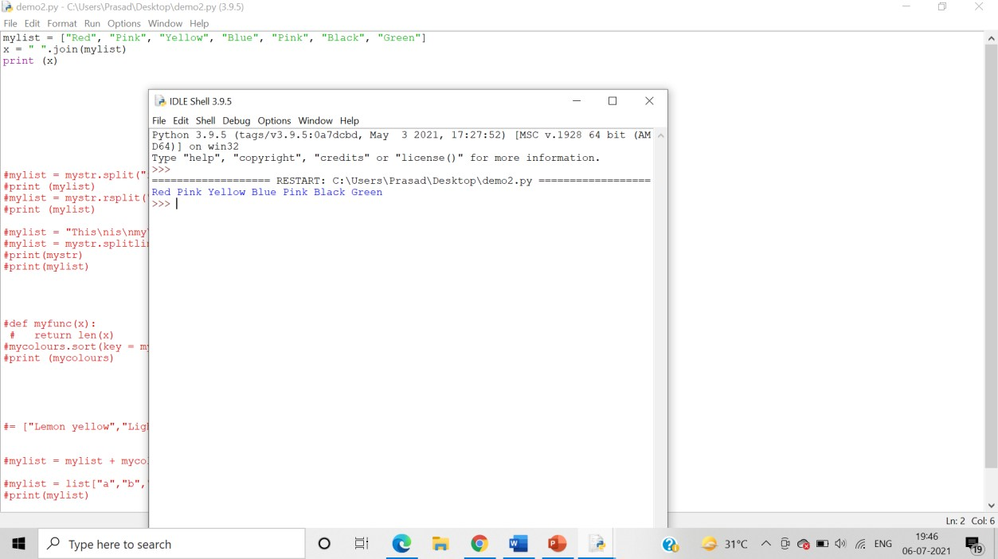

* 1. Use ‘for in’

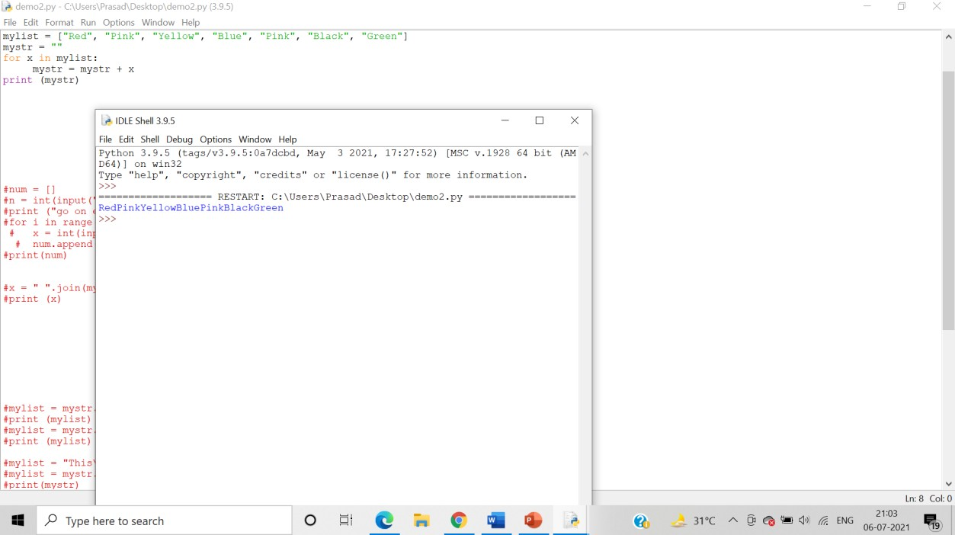

1. Write a program demonstrating declaration, accessing- Indexing and splicing of tuples and its elements.

**Algorithm**:-

Step 1: A tuple is declared by placing all the items (elements) inside parentheses (), separated by commas and assigning it to a variable.

Step 2: To access the tuple items refer to the index number insed the index operator[] (Indexing).

Step 3: By inputting a range of indexes by specifying where to start and where to end the range we can print a subset of the tuple (splicing)

Answer: Program demonstrating declaration, accessing- Indexing and splicing of tuples and its elements:

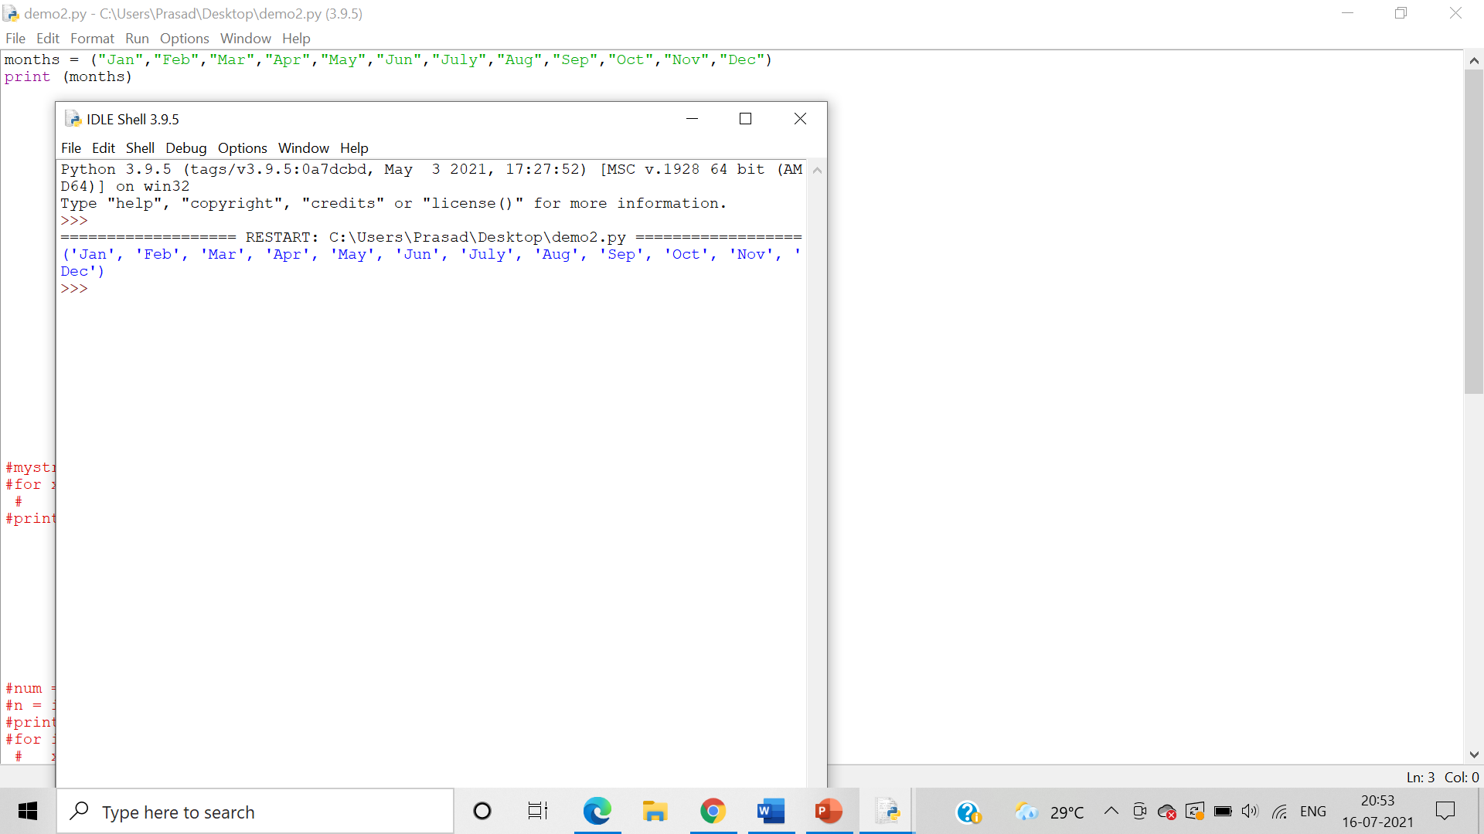

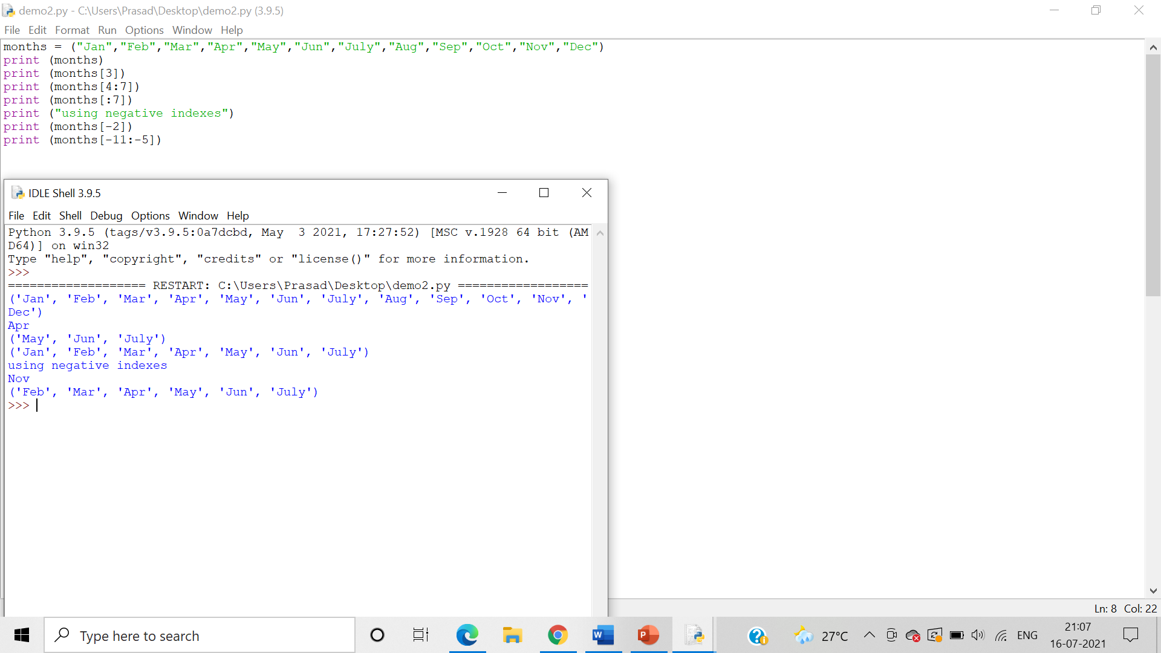

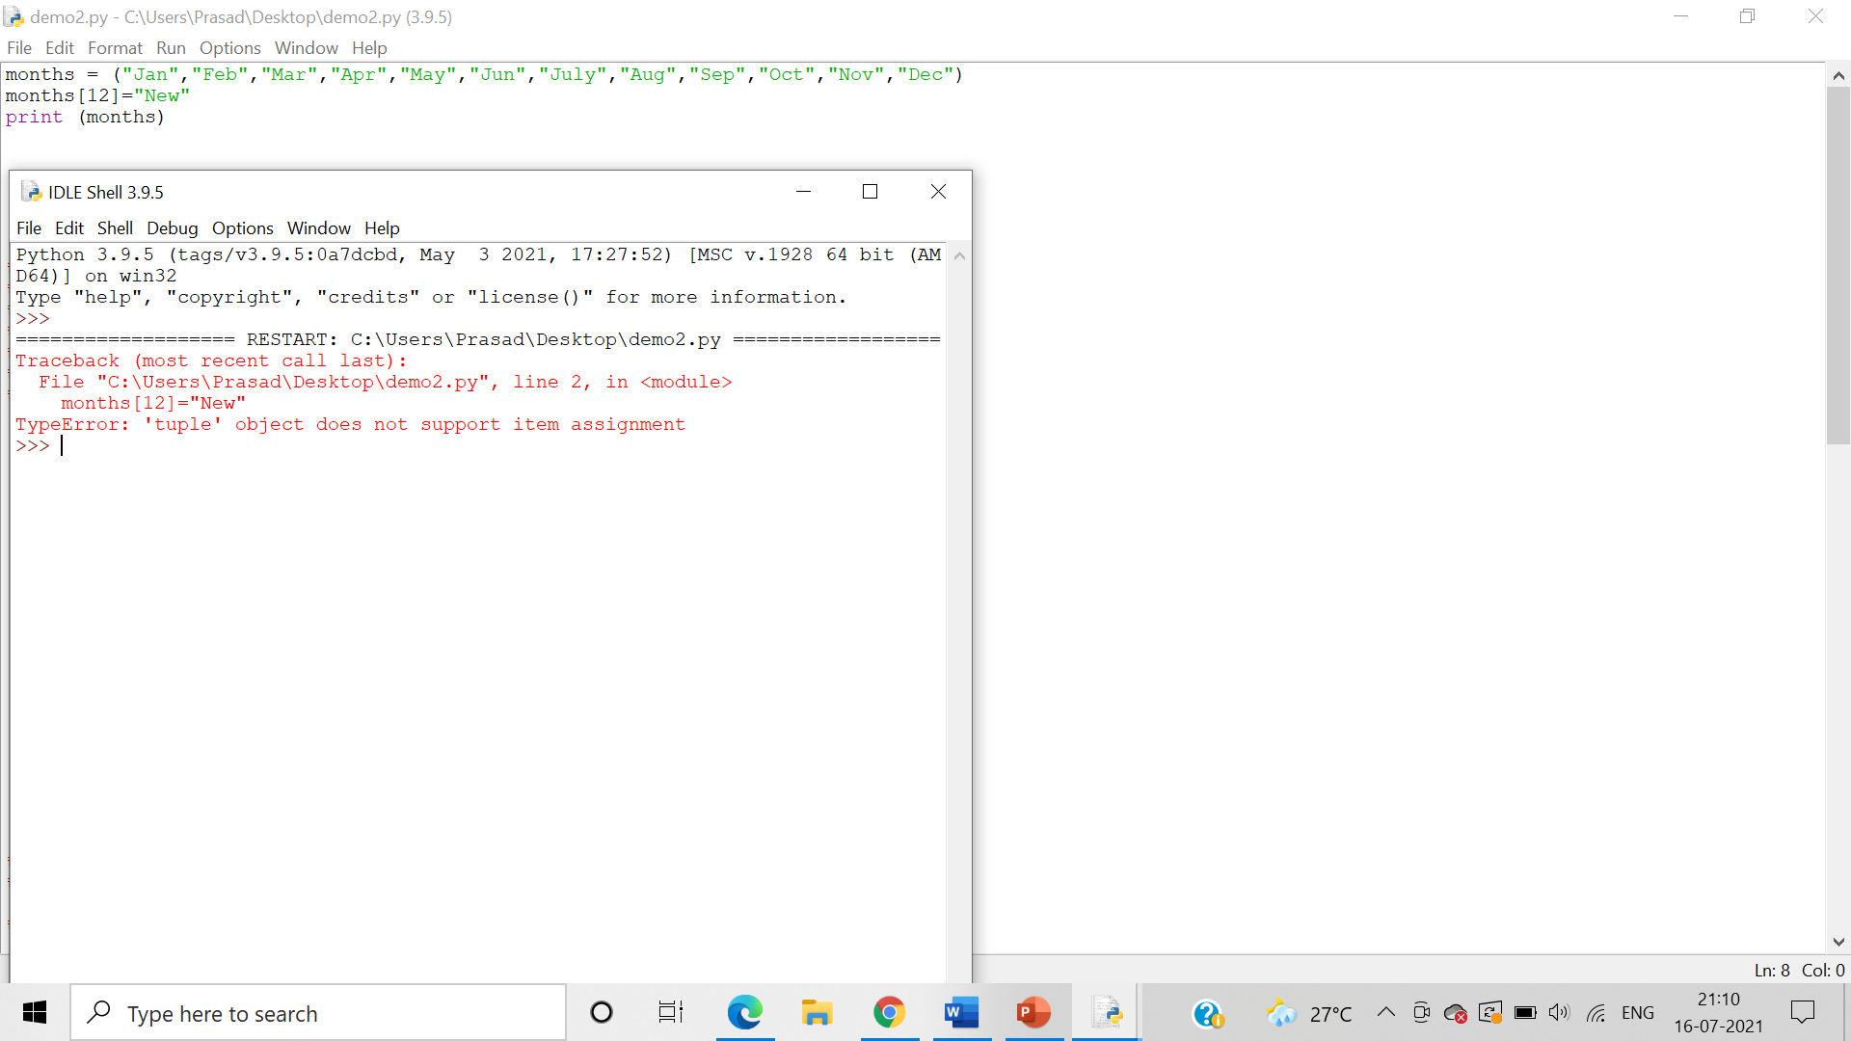

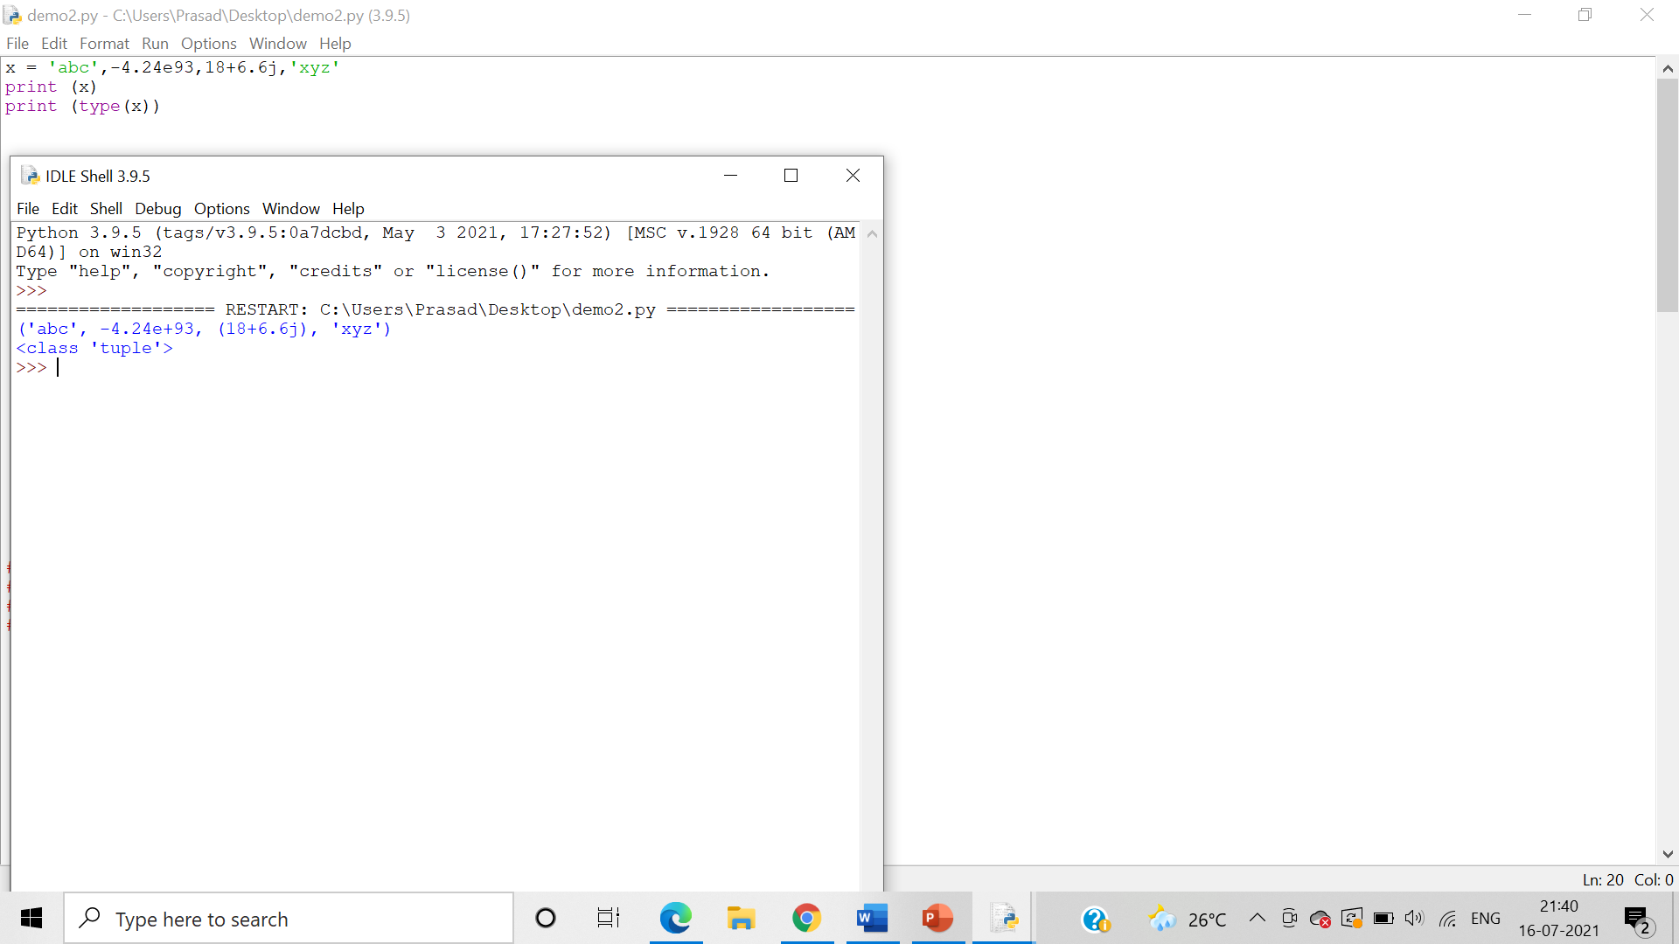

1. Write a program demonstrating input of tuple elements from the user

**Algorithm**:-

Step 1: Use the input() function to take user input and assign it to a variable

Step 2: Use the split function to split each value in the variable with a “,” and assign it a new tuple variable.

Step 3: Print the tuple variable

Answer: Program demonstrating input of tuple elements from the user:

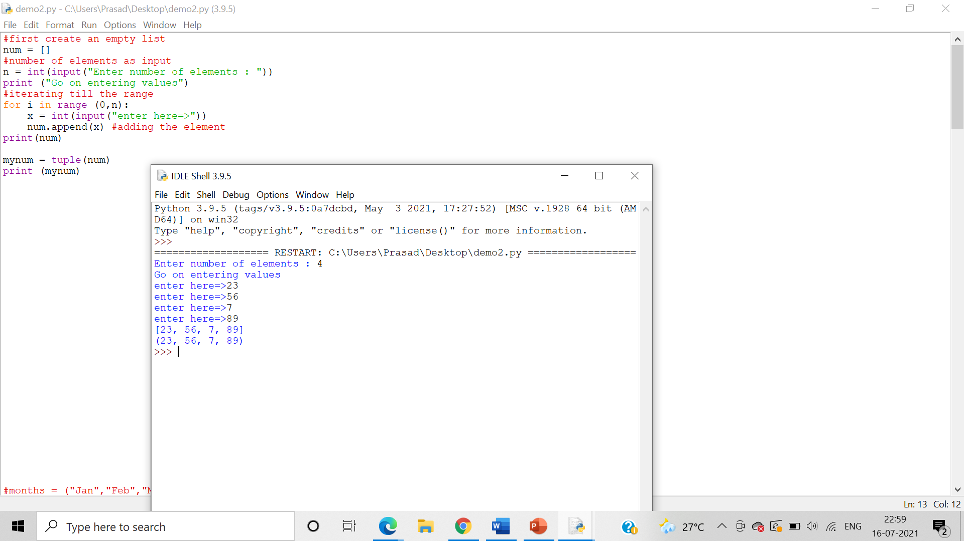

1. Write a program demonstrating printing of tuple elements using for in and range() function

**Algorithm**:-

Step 1: Declare a tuple by assigning it to a variable

Step 2: The range() gives us a sequence of numbers in between the two integers given to it.

Step 3: We can use the in and range() function to print the tuple elements using a for loop.

Answer: Program demonstrating printing of tuple elements using “for in”:

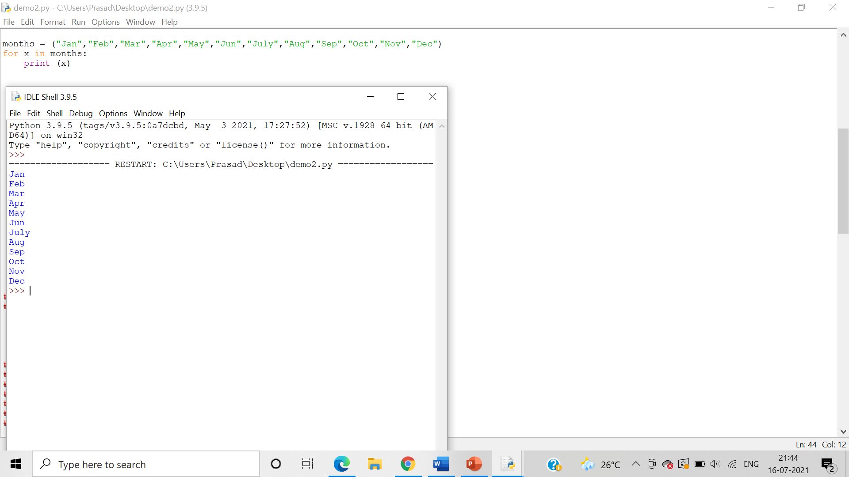

Program demonstrating printing of tuple elements using range() function:

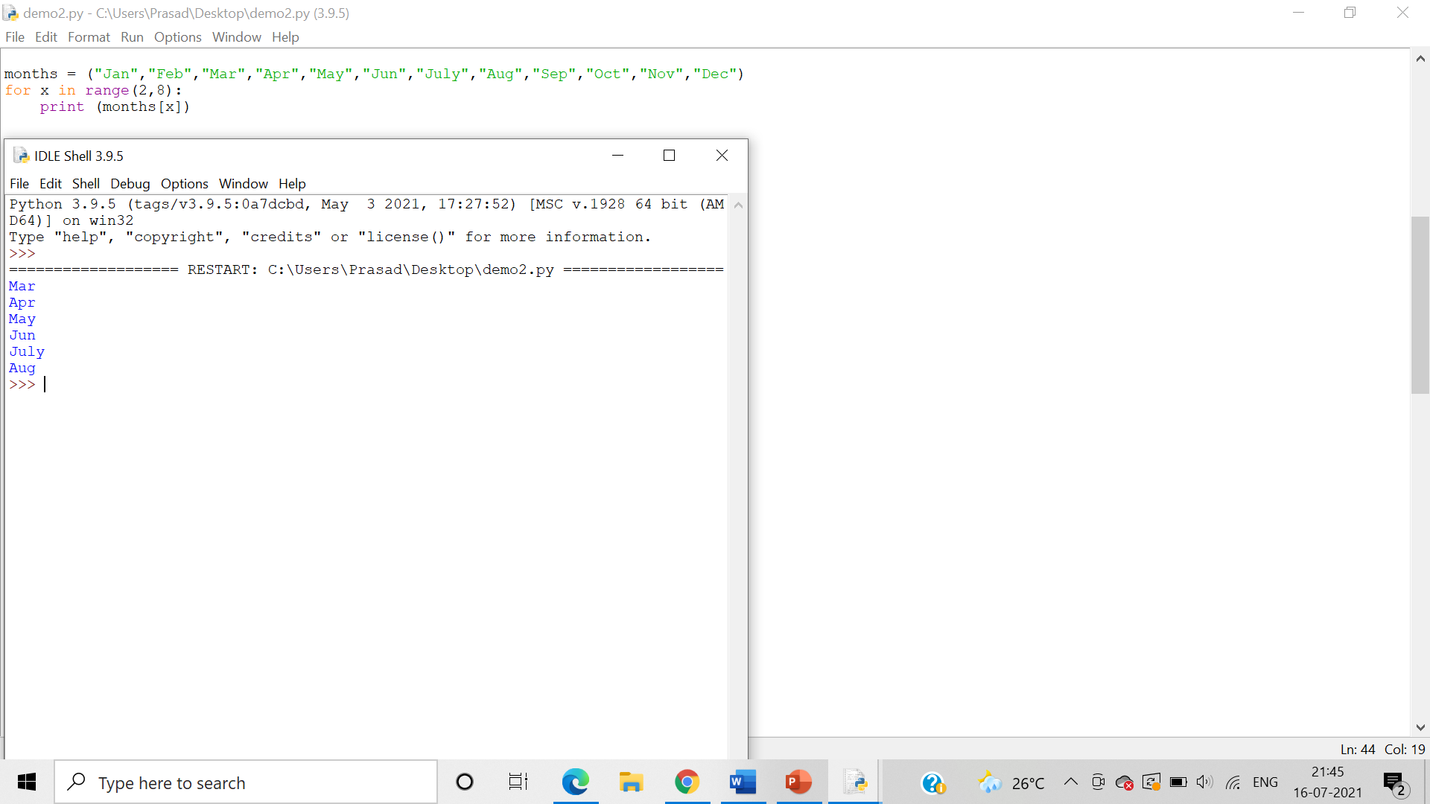

1. Write a program demonstrating len() and del() function on tuple.

**Algorithm**:-

Step 1:   The len() function is used to obtain the length of the tuple

Step 2: The del() function **deletes all the elements in range** starting from index ‘a’ till ‘b’ mentioned in arguments.

Answer: Program demonstrating len() function on tuple:

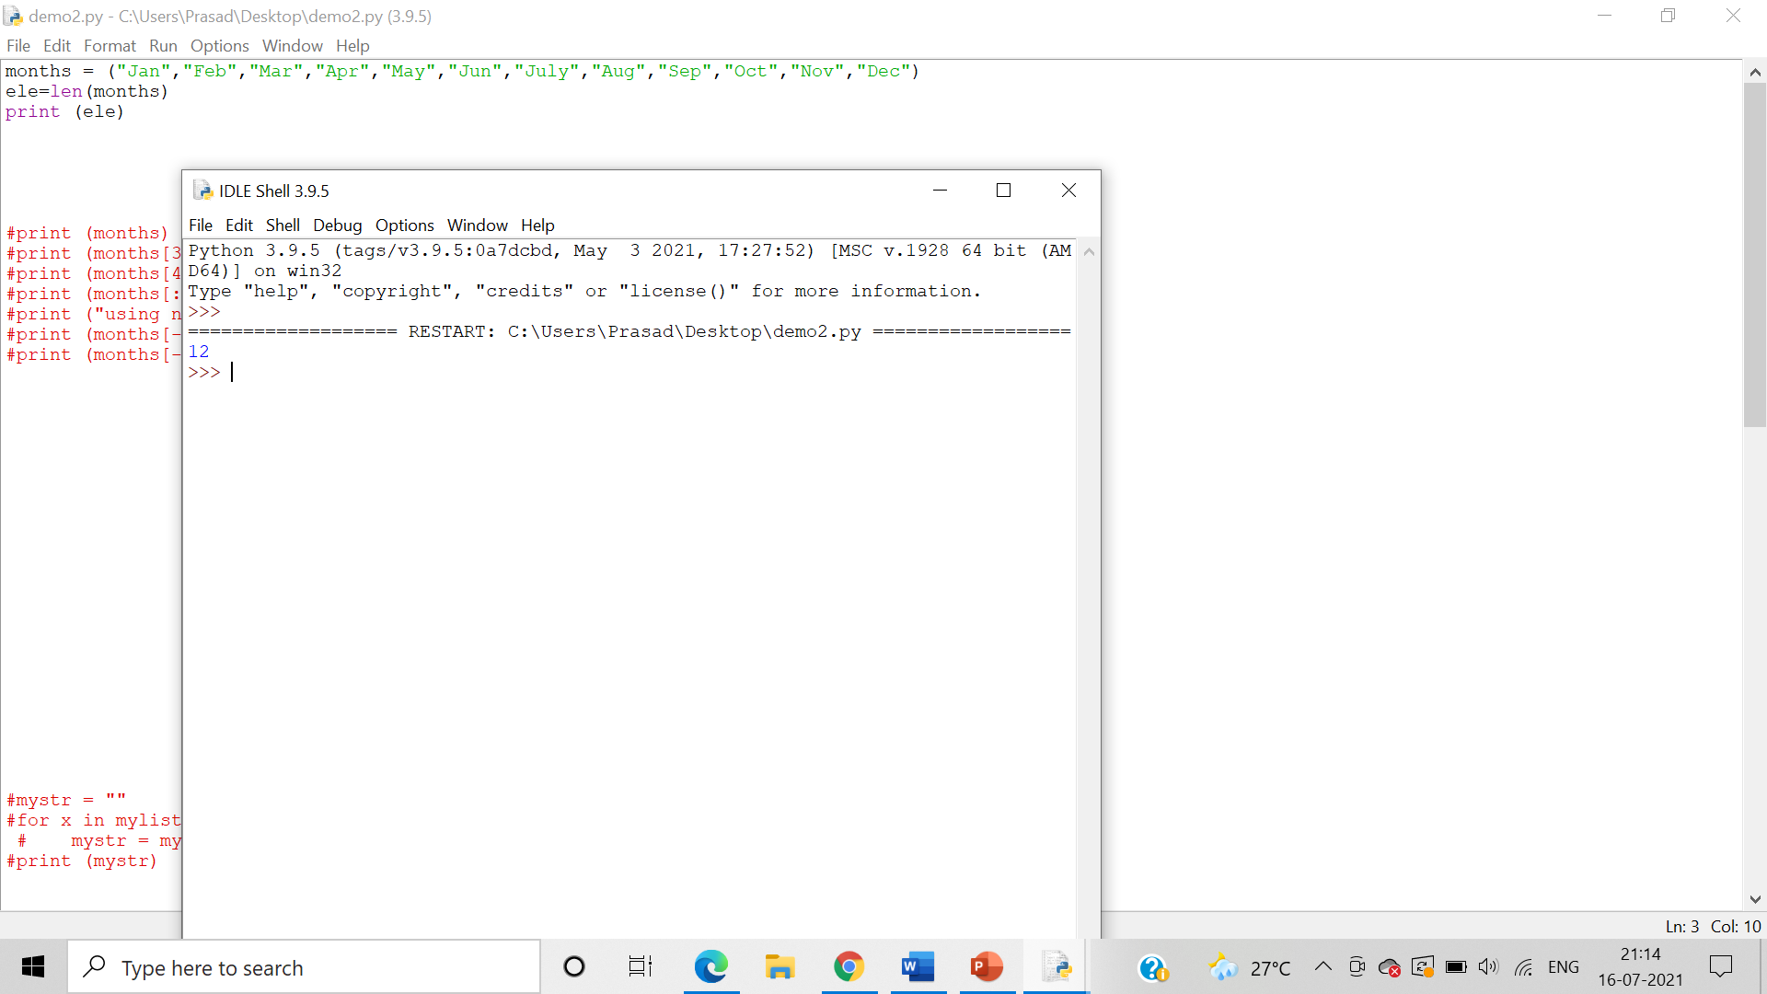

Program demonstrating del() function on tuple:

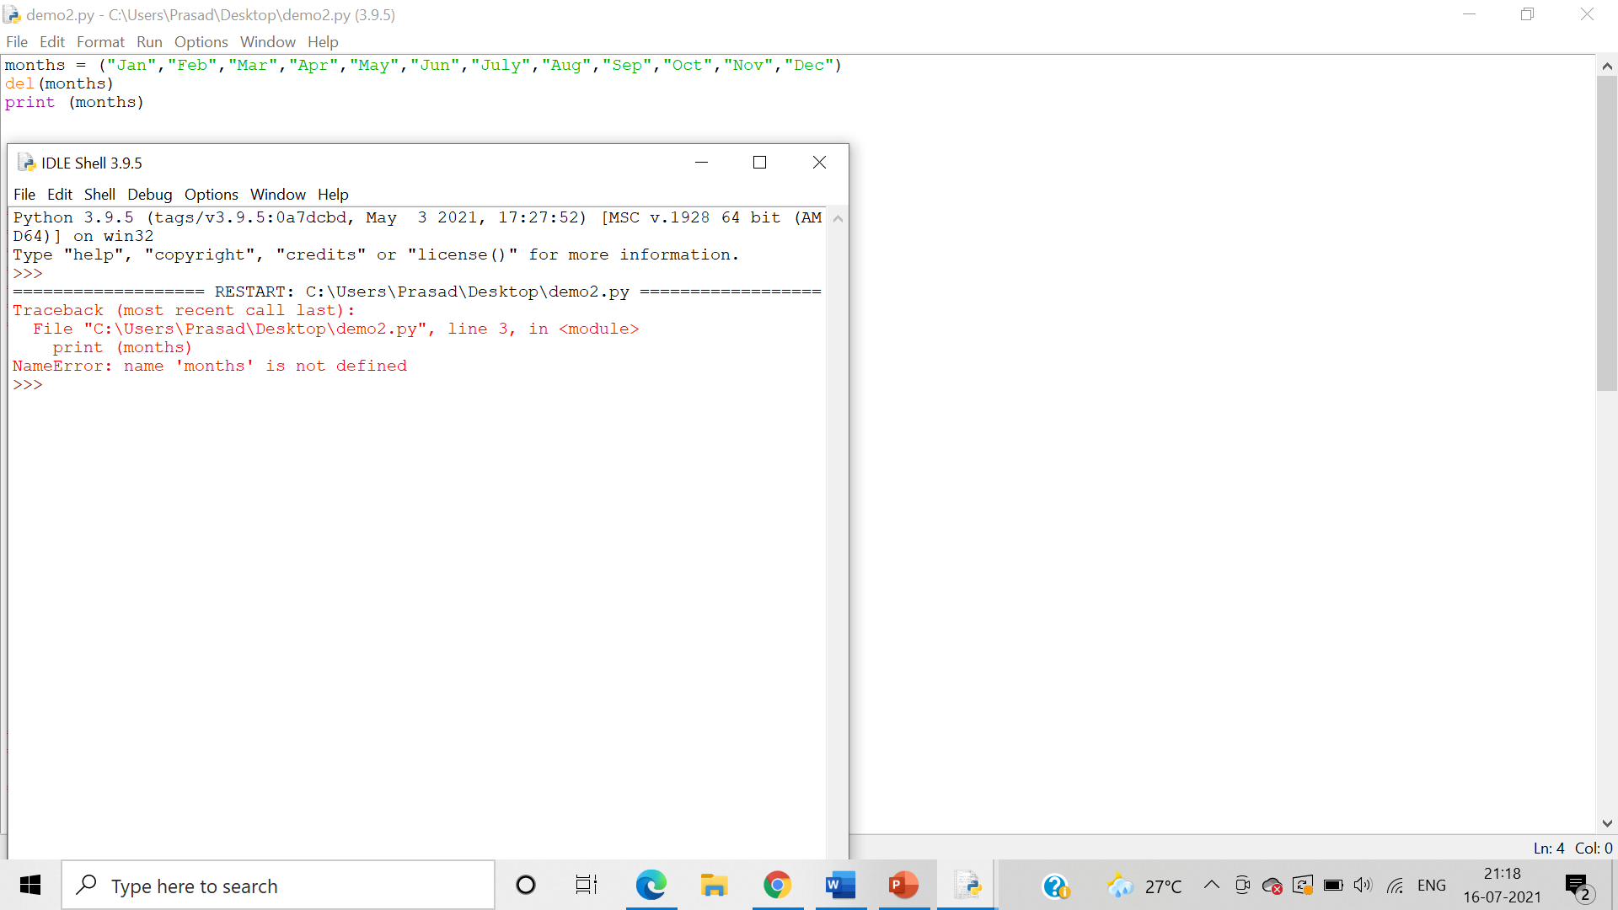

1. Write a program demonstrating usage of ‘+’ and ‘*’ operators on tuple

**Algorithm**:-

Step 1: The ‘+’ operator is used to concatenate the 2 tuples into a single tuple.

Step 2: The ‘*’ operator is used to to**multiply the tuple “n” times**

Answer: Program demonstrating usage of ‘+’ operators on tuple:

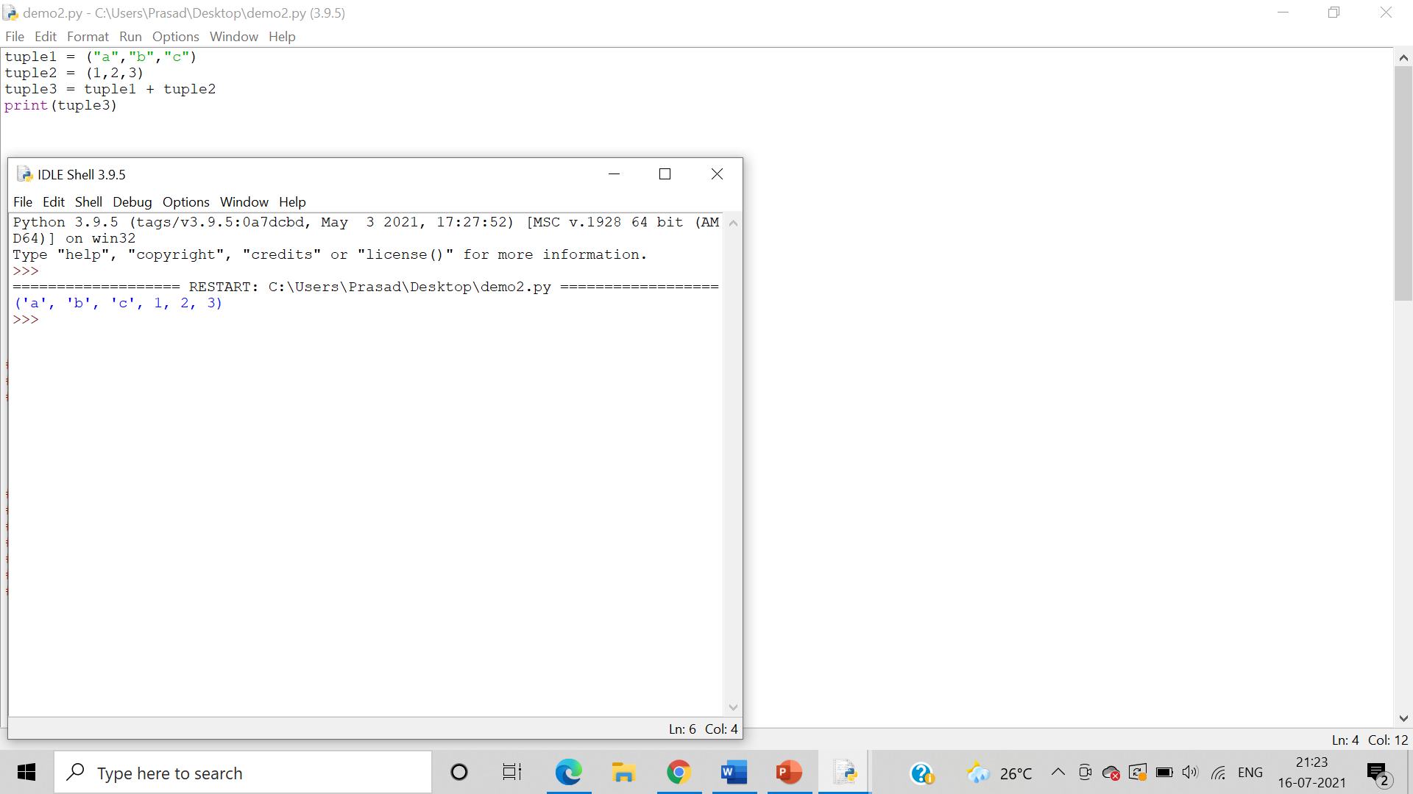

Program demonstrating usage of ‘*’ operators on tuple:

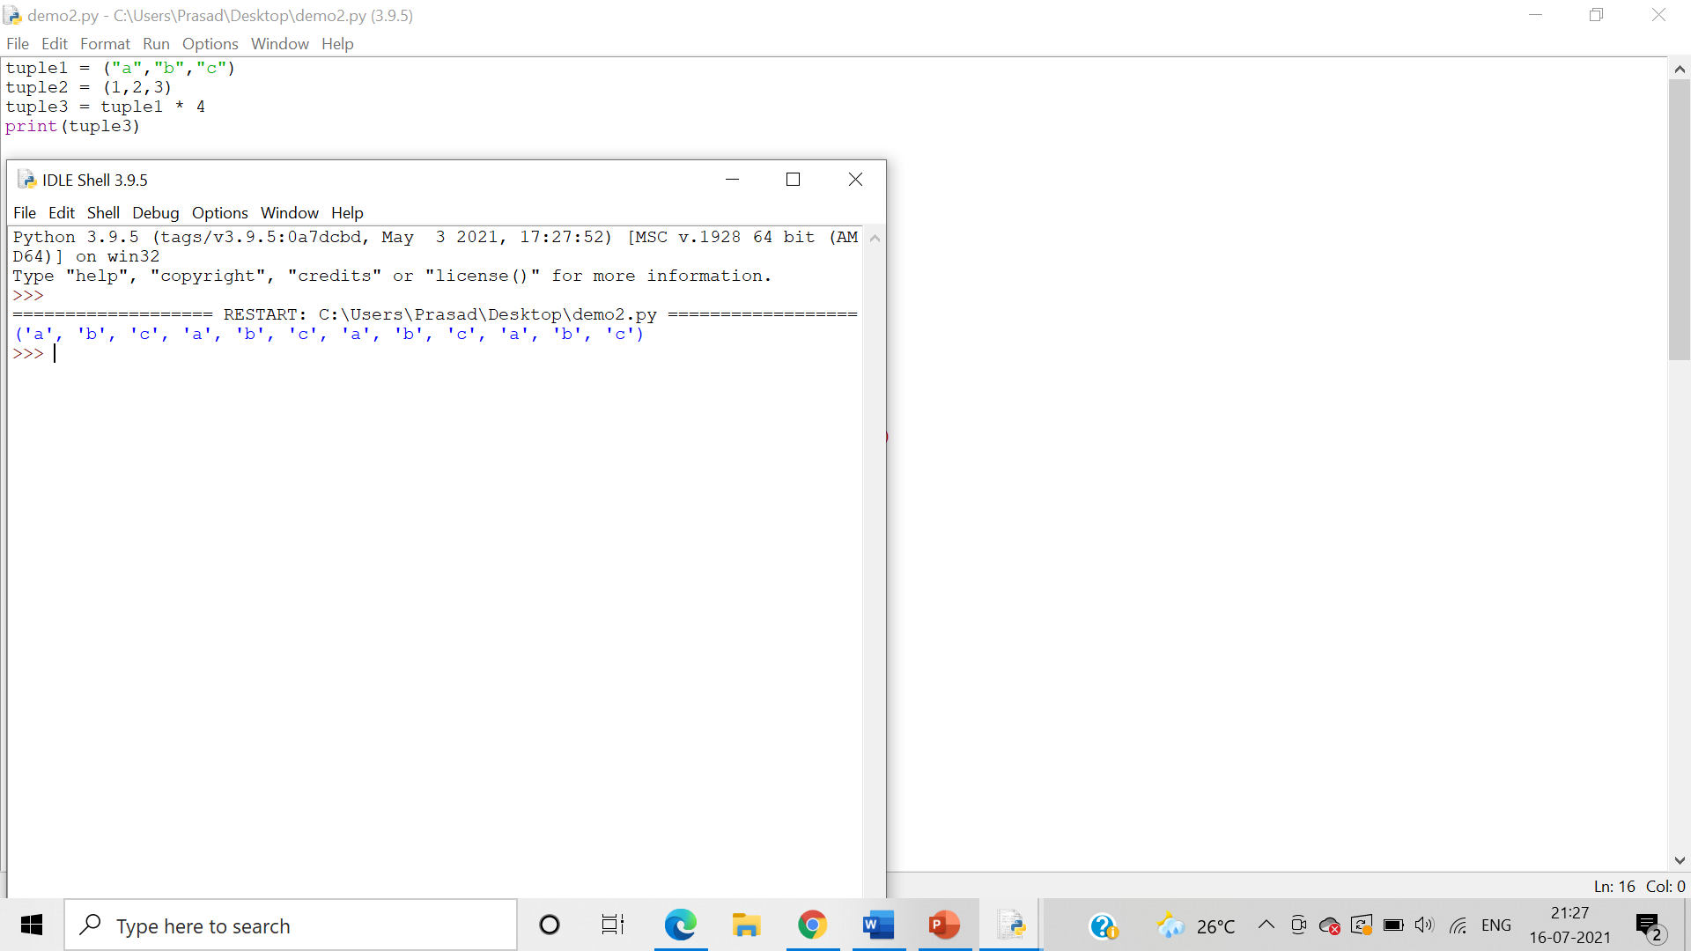

1. Write a program demonstrating “in” and “not in” keywords on tuple

**Algorithm**:-

Step 1: - The ‘in’ operator is used to **check if an element is present** in the tuple or not. Returns true if element is present in tuple else returns false.

Step 2:  The ‘not in’ operator is used to **check if an element is not present** in the tuple or not. Returns true if element is not present in tuple else returns false.

Answer: Demonstrating “in” keyword on tuple:

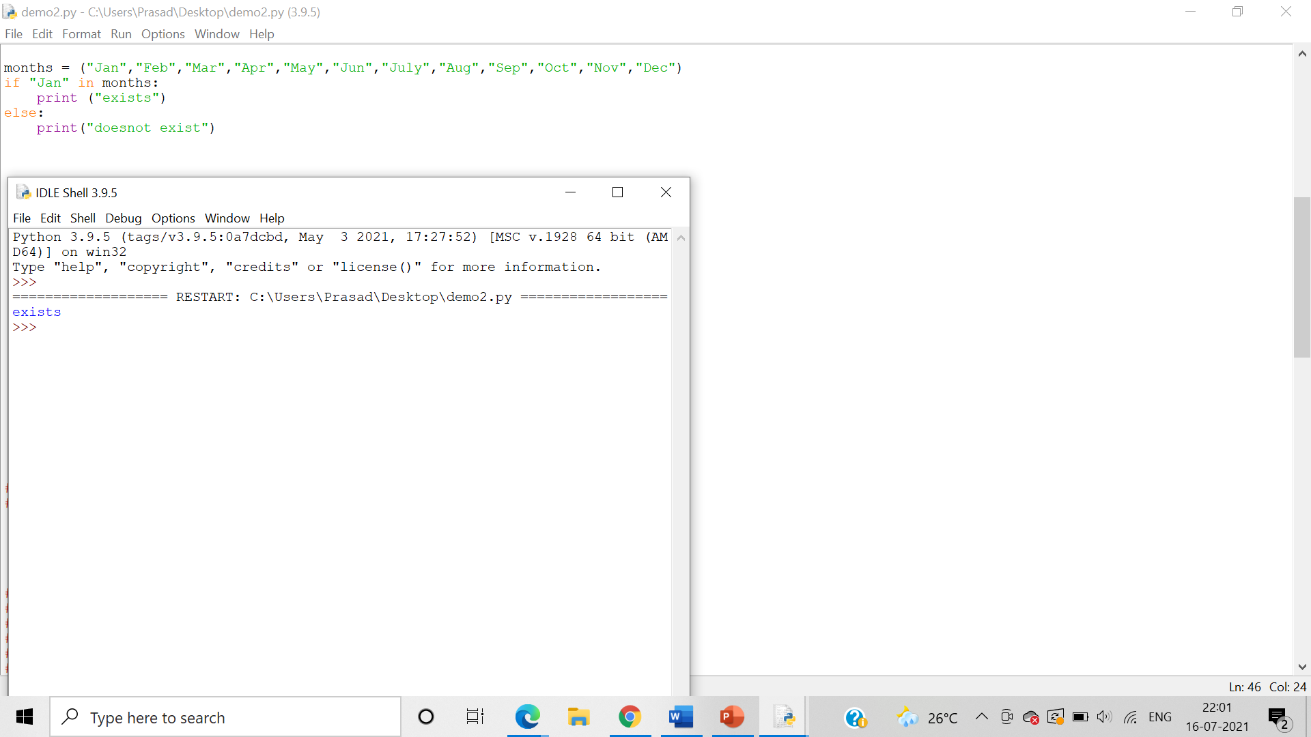

Demonstrating “not in” keyword on tuple:

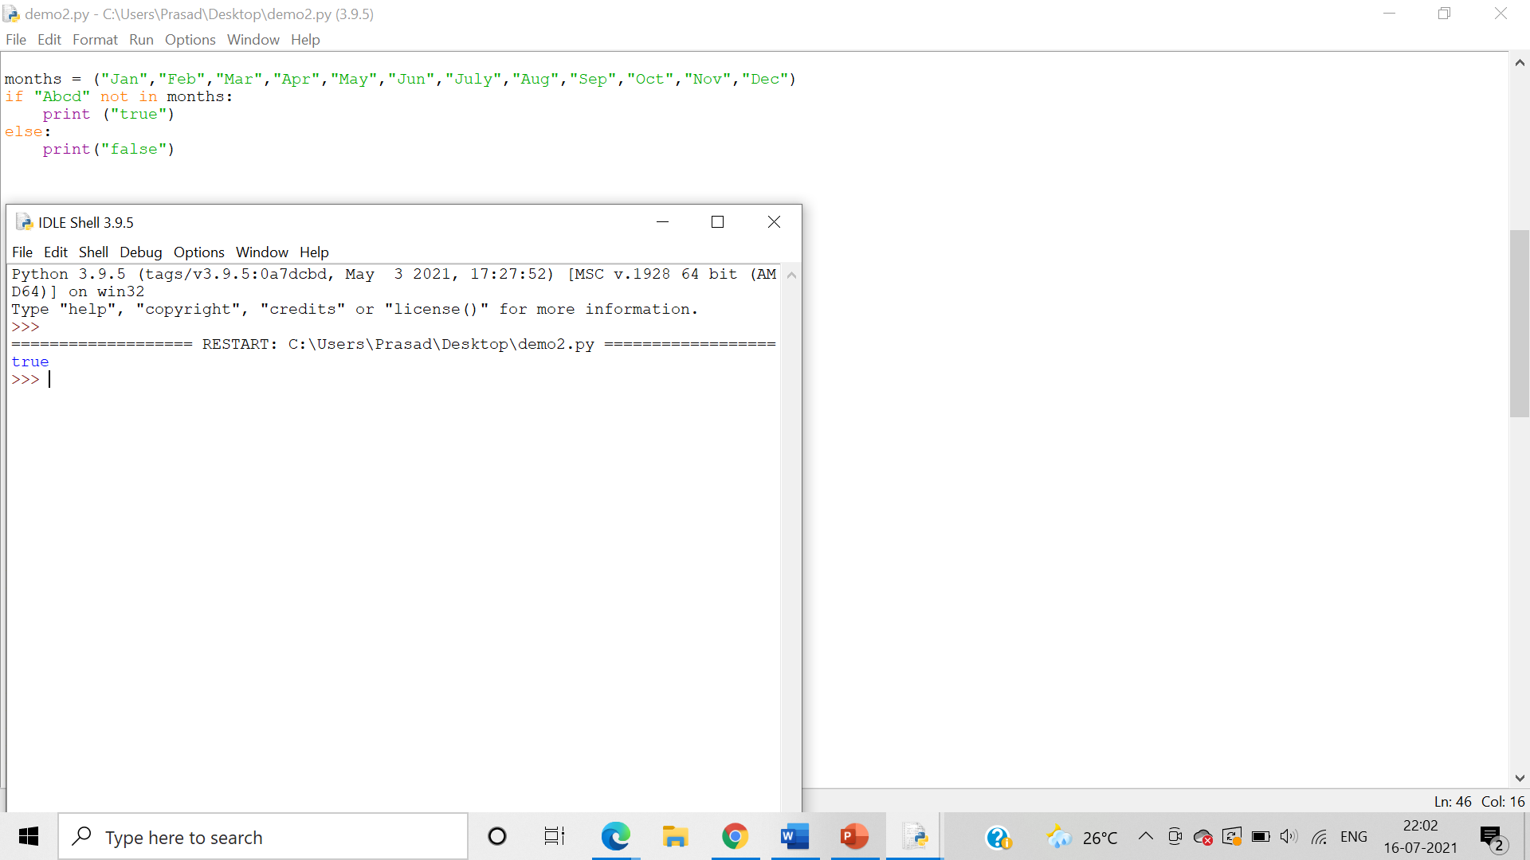

1. Write set of programs for demonstrating the usage of all the different Tuple methods along with their variations

**Algorithm**:-

Step 1: The count() method returns the number of times a specified value occurs in a tuple

Step 2: The index () searches the tuple for a specified value and returns the position of where it was found. It raises an exception if item is not found

Answer: Programs for demonstrating the usage of count() :

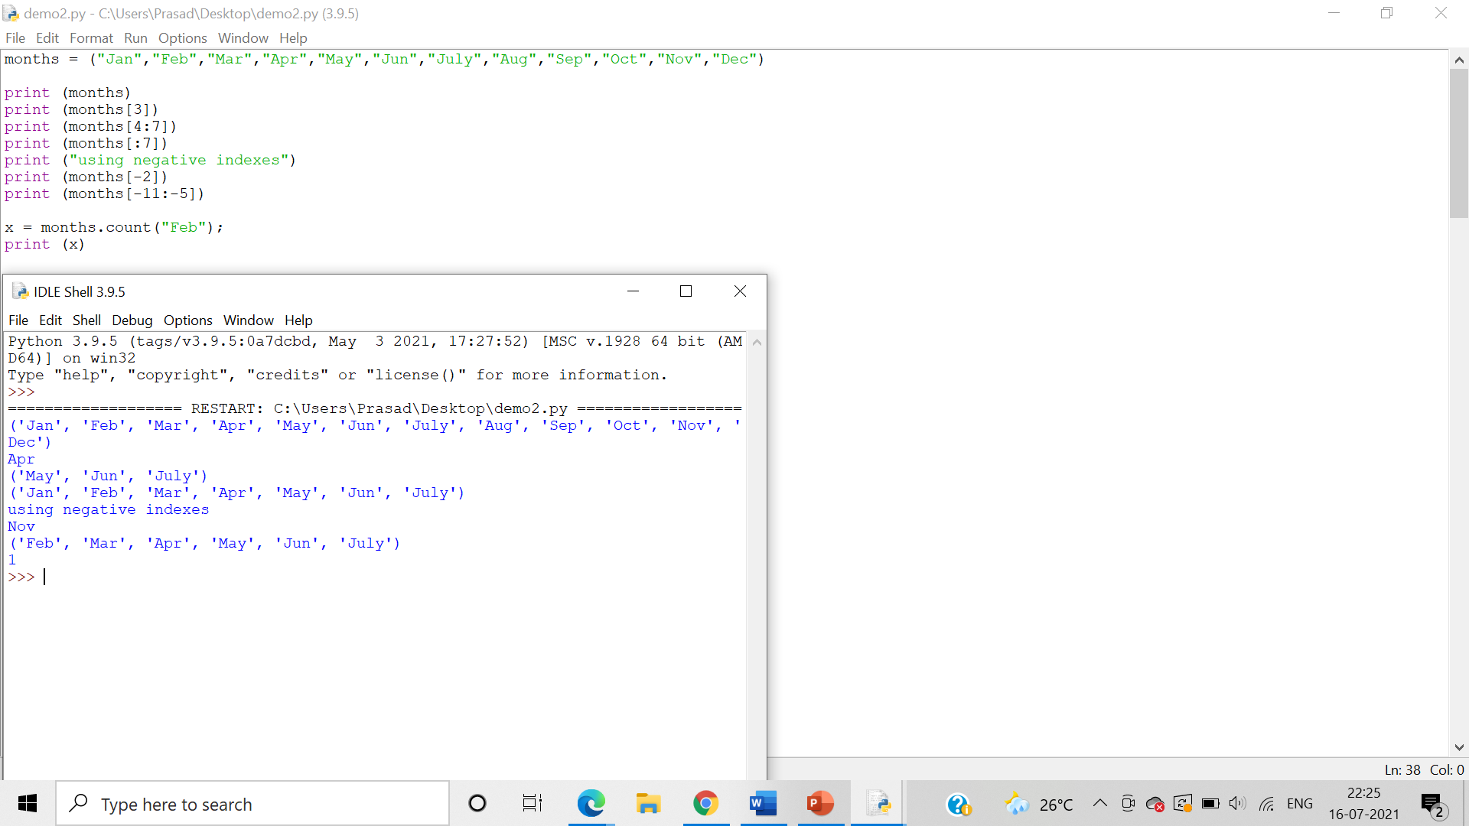

Programs for demonstrating the usage of index() :

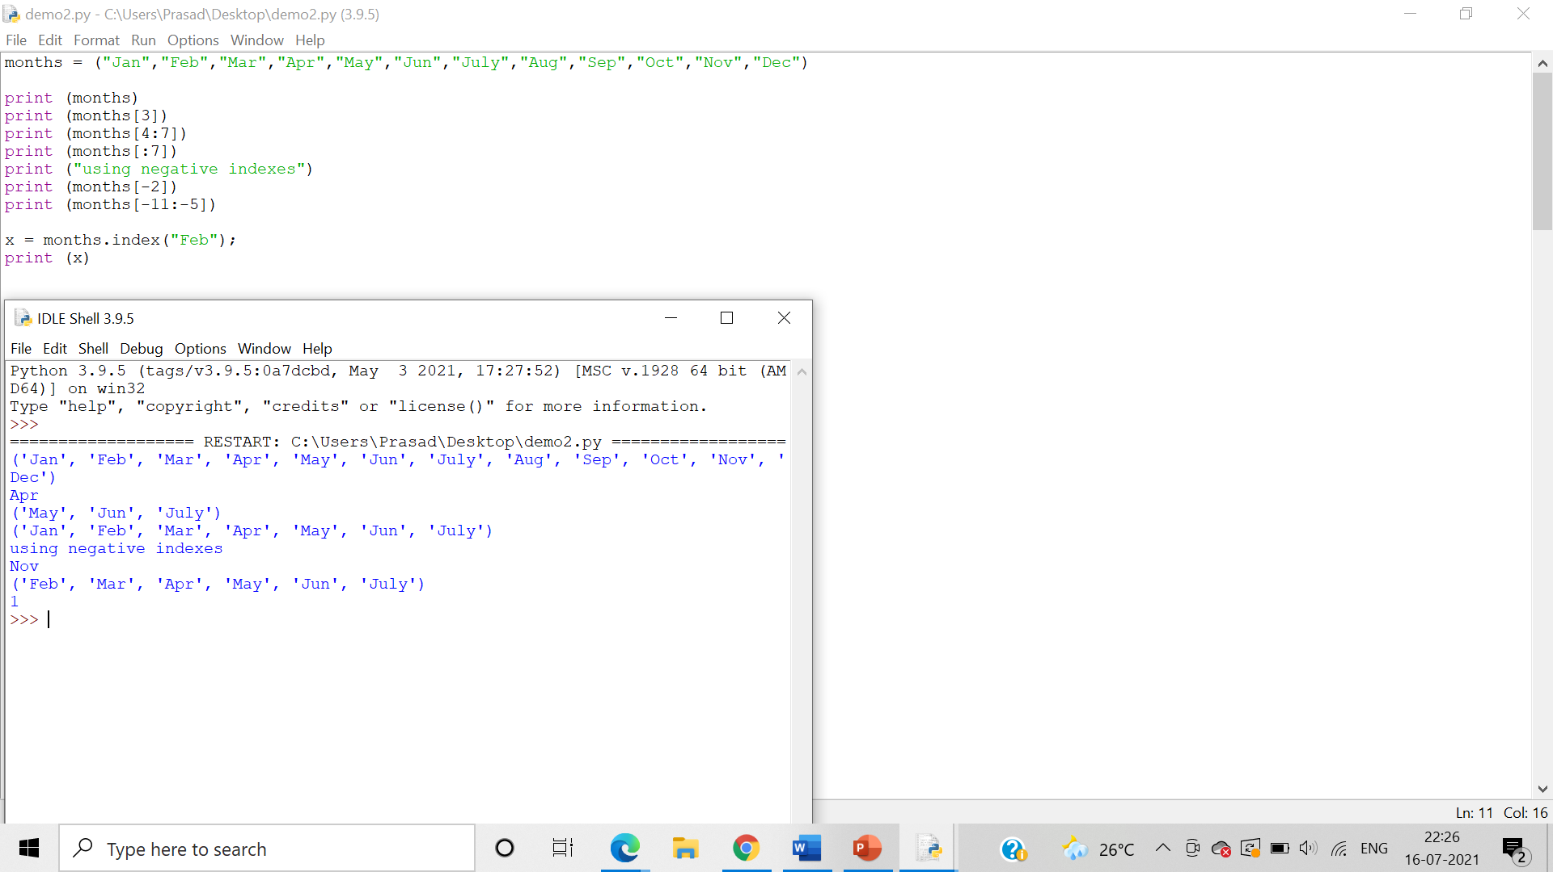

rindex() is not applicable in tuples:

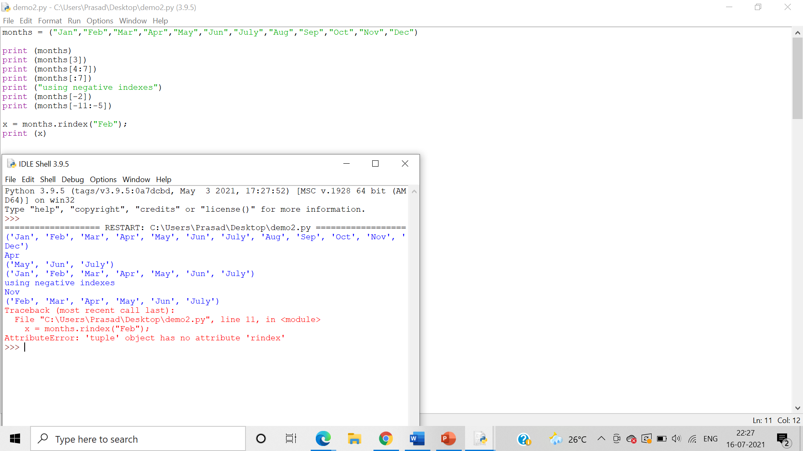

1. Write a Python Program to Calculate the Average of Numbers entered by the user in the user-defined list

**Algorithm**:-

Step 1: Declare a User defined list and assign it to a variable.

Step 2: For the user defined range use the avg=sum(a)/n formula to calculate the the average of the numbers present in the user defined list.

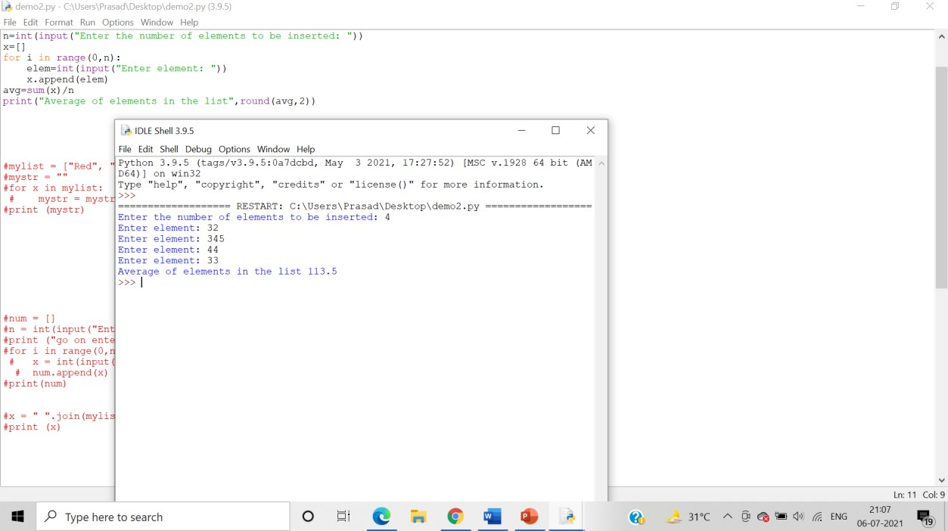

1. Write a Program to Generate Random Numbers from 1 to 10 and add them in a defined list

Algorithm:-

Step 1: Import random function

Step 2: Input the range of the list

Step 3: Initialize an empty list

Step 4: Set i=0 and use a while loop where when i<0 the loop executes its task.

Step 5: Using The randint() function to generate random integer and use the append() function to add the integer to the list.

Step6: Print the list.

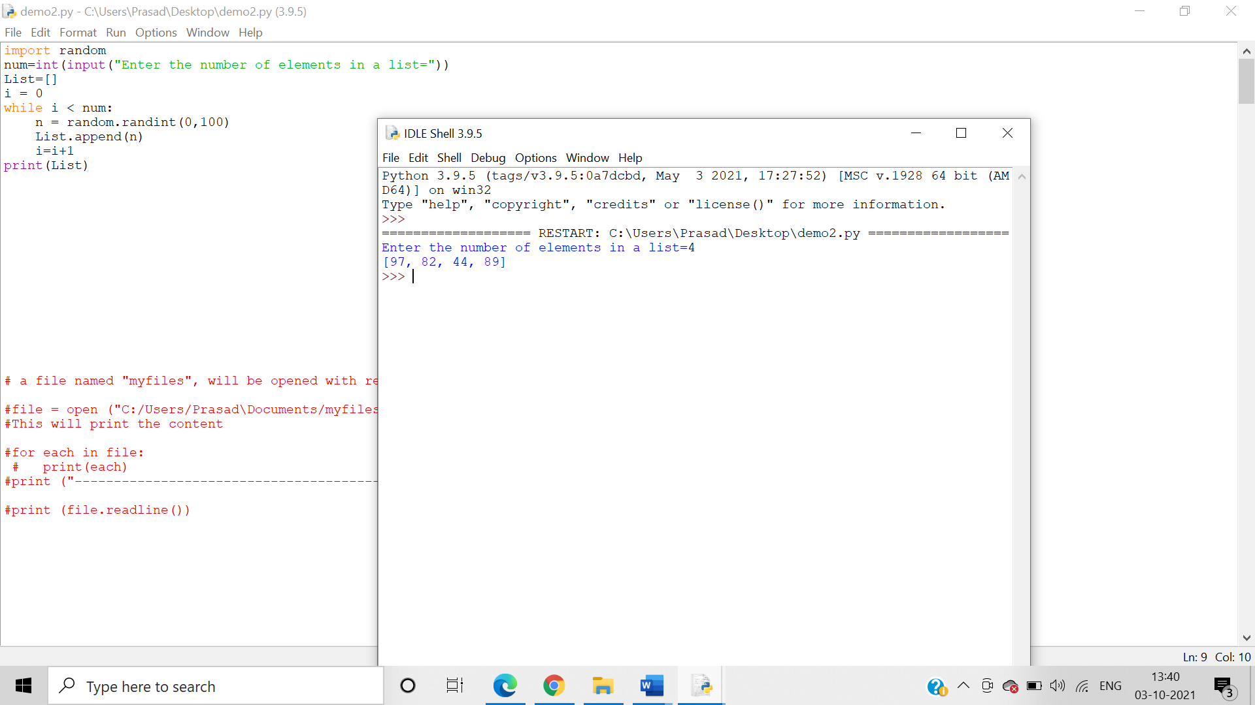

18.   Write a program demonstrating a creation of 2D list and print it.

**Algorithm**:-

Step 1: Intialise the number of rows and columns

Step 2: Use Nested for loops to print out the 2D matrix in given dimensions.

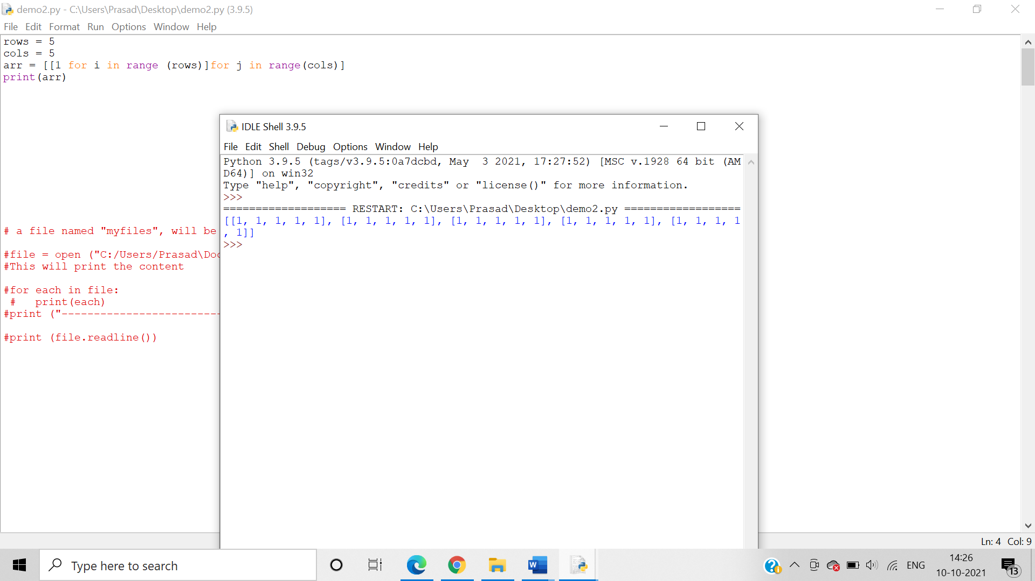

19. Write a program to create a user defined 2D list and print it. Take dimensions from the user.

**Algorithm**:-

Step 1: Input the number of rows and columns required.

Step 2: Initialize a empty array list

Step 3: Use Nested for loops so as to initialize the matrix to the user defined rows and columns.

Step 4: Input the values of the matrix.

Step 5: Use the append function to append the values to the matrix of user defined rows ad columns.

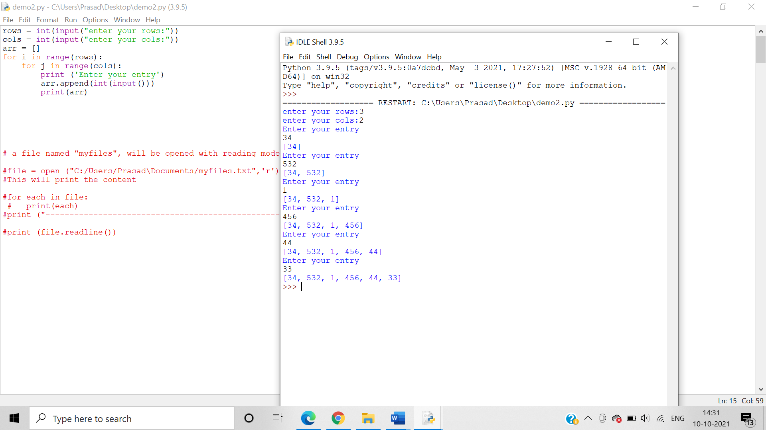

20. Write a program for addition of two matrices

**Algorithm**:-

Step 1:Input the number of rows and columns.

Step 2: Initialize 2 empty arrays and a result matrix where all values are 0.

Step 3: Use Nested for loops so as to initialize the matrix’s to the user defined rows and columns.

Step 4: Input the values of the 2 matrix’s so as to obtain a 3x3 matrix.

Step 5: Use nested for loops and use the index position of each values of both the matrix as to add each value in a given position of a matrix to the corresponding value of the same value in the second matrix.

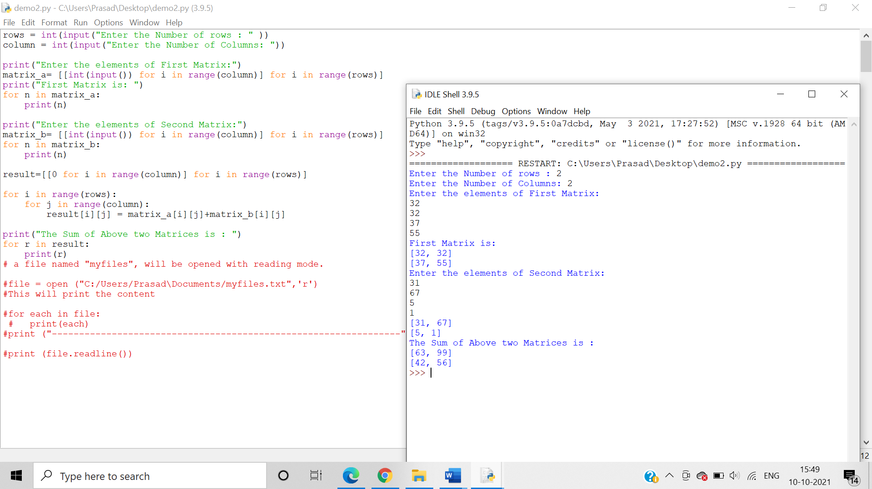

21. Write a program for subtraction of two matrices

**Algorithm**:-

Step 1:Input the number of rows and columns.

Step 2: Initialize 2 empty arrays and a result matrix where all values are 0.

Step 3: Use Nested for loops so as to initialize the matrix’s to the user defined rows and columns.

Step 4: Input the values of the 2 matrix’s so as to obtain a 3x3 matrix.

Step 5: Use nested for loops and use the index position of each values of both the matrix as to subtract each value in a given position of a matrix to the corresponding value of the same value in the second matrix.

22. Write a program for multiplication of two matrices